What makes system reliable –

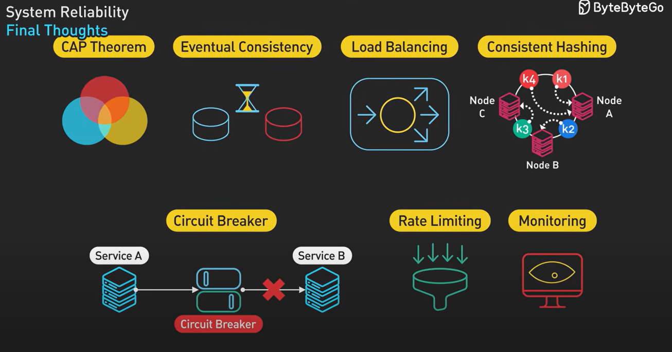

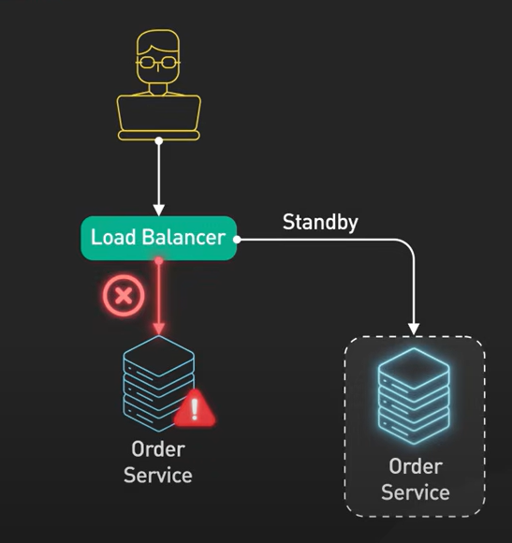

CAP Theorem – distributed system can provide at most 2 out of three consistency, availability and partition tolerance.

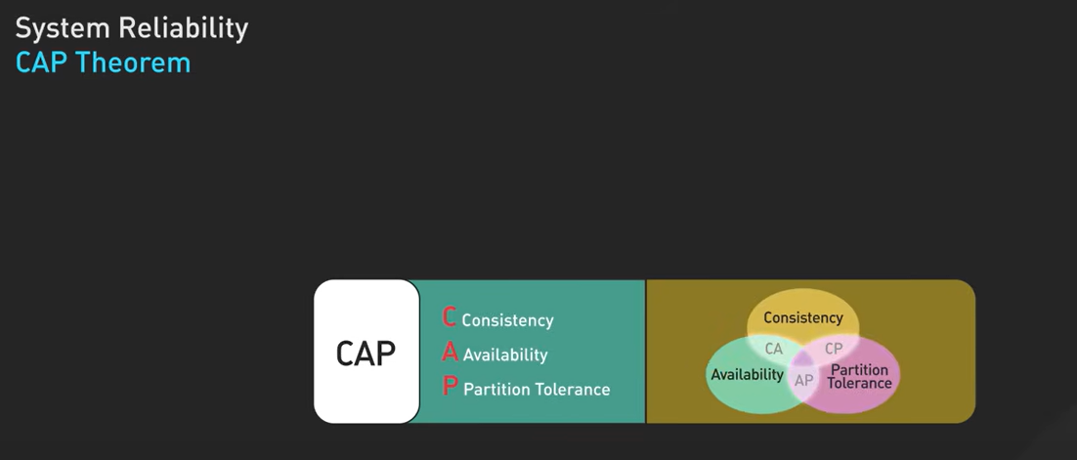

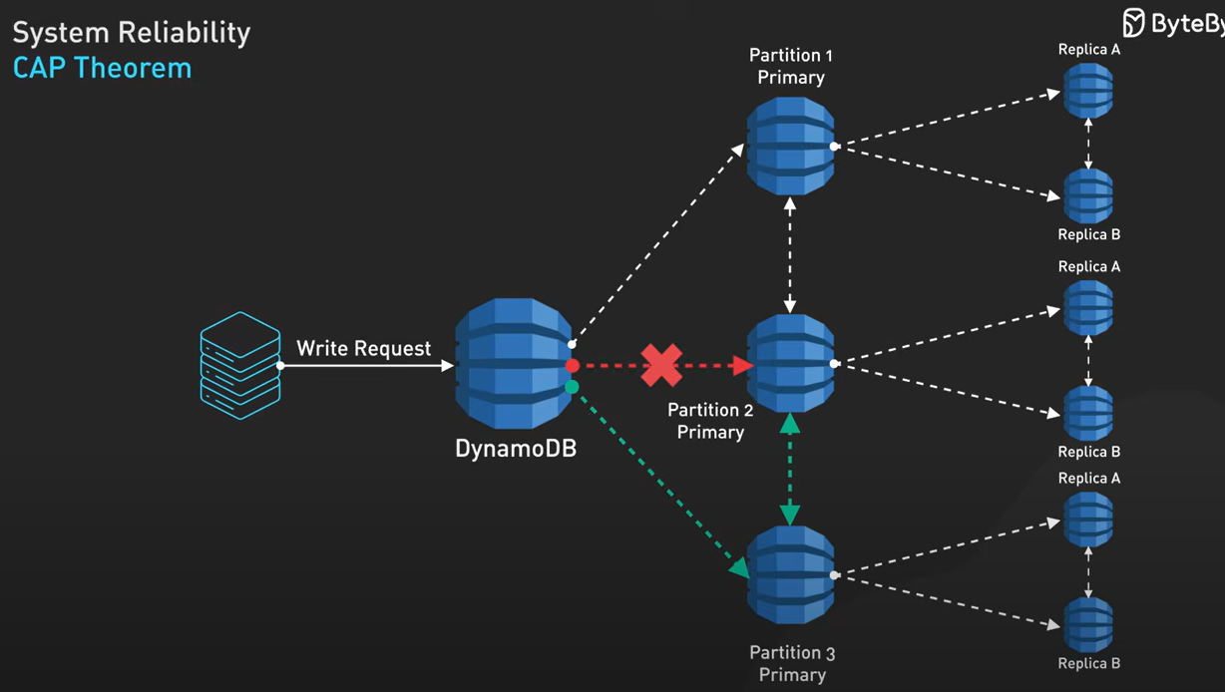

Eventual consistency –

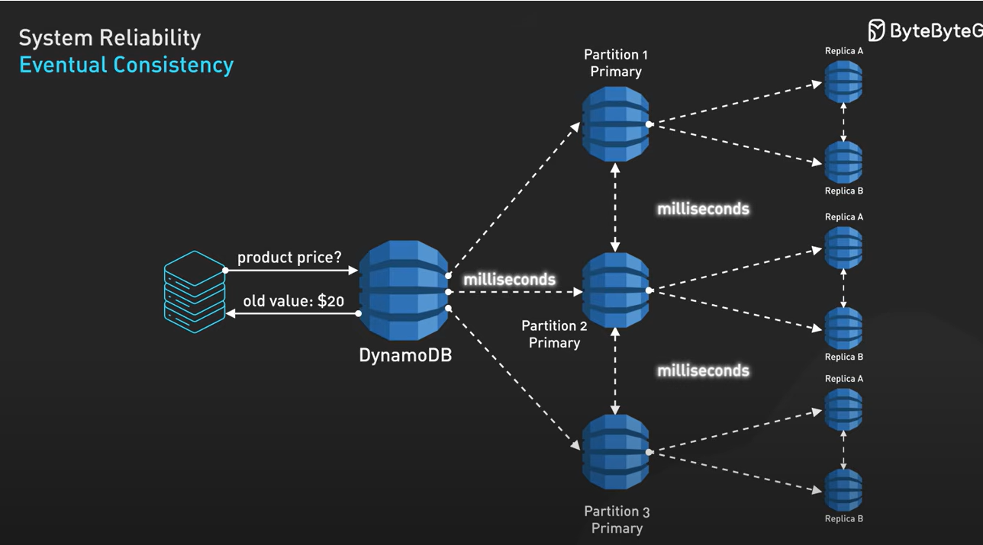

Load balancing – now a days load balancers are very smart.

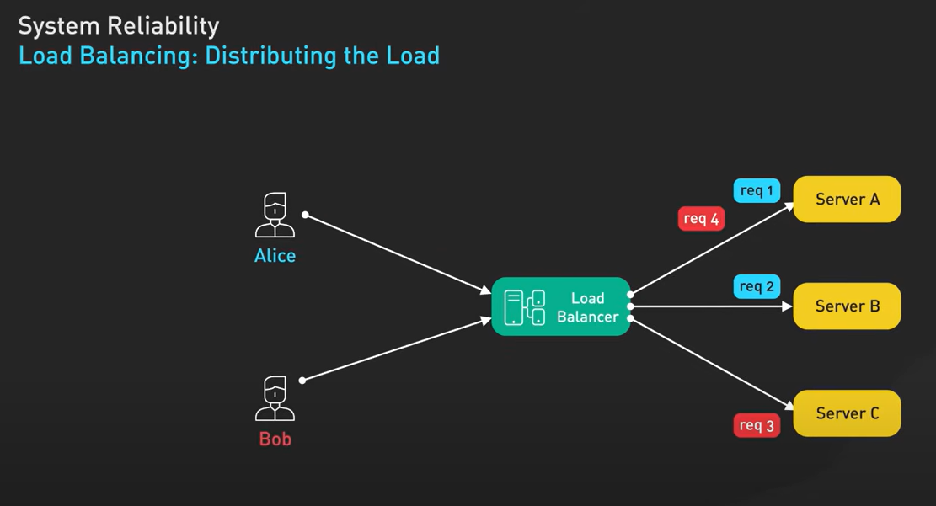

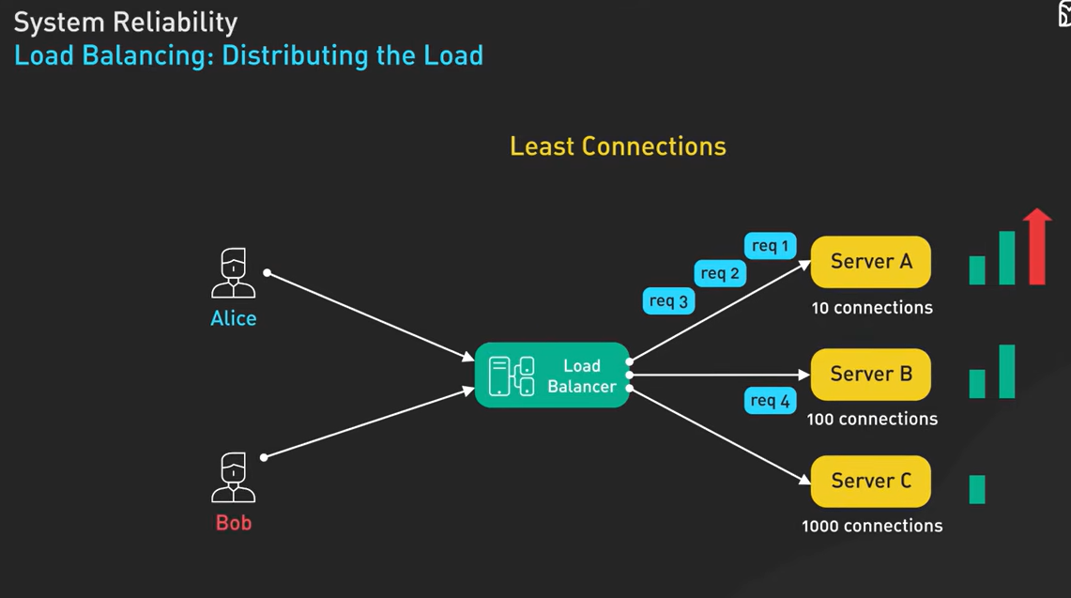

Consistent hashing – same client goes to same serve for maintaining session state –

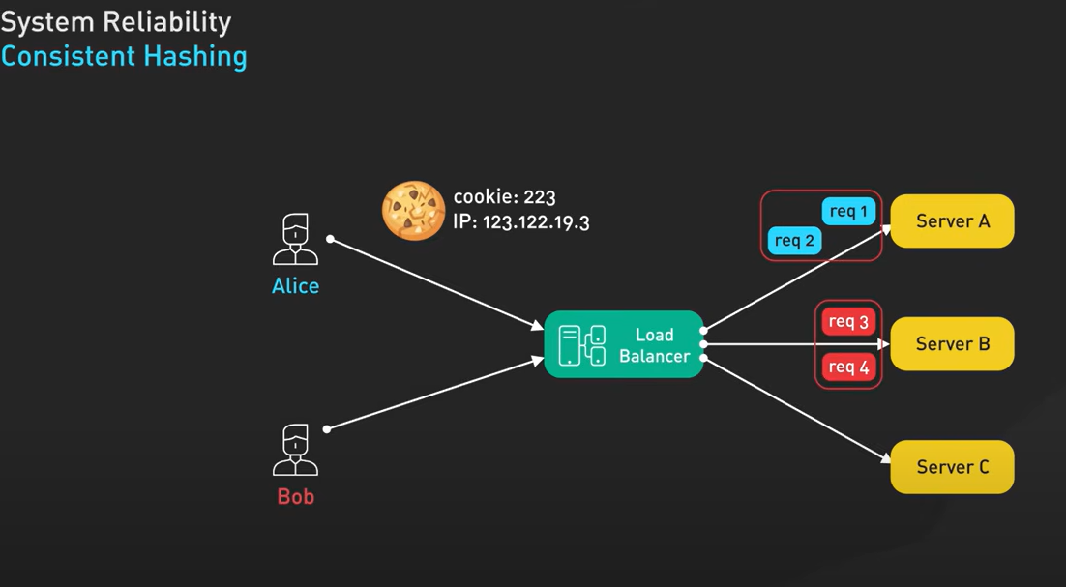

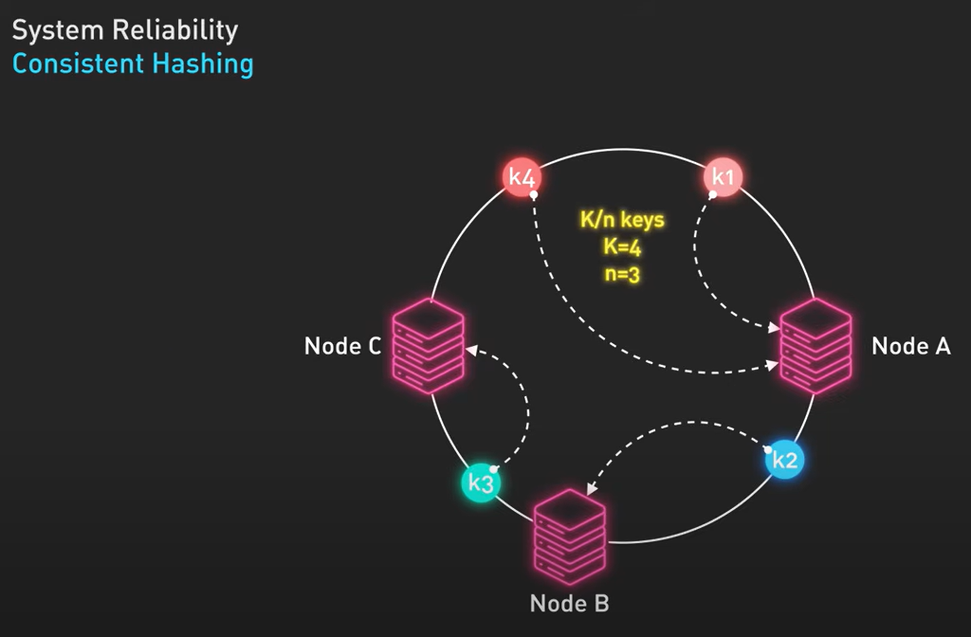

Circuit breakers – fast failure are better than slow failure to consume resources.

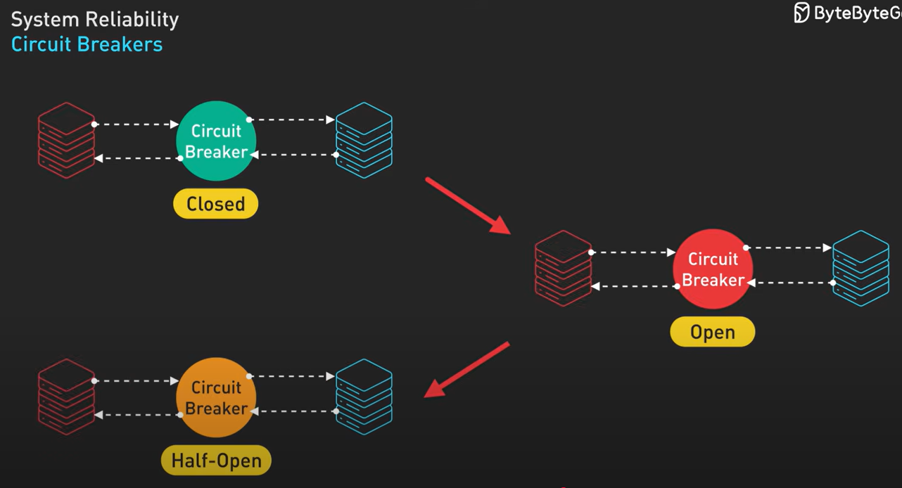

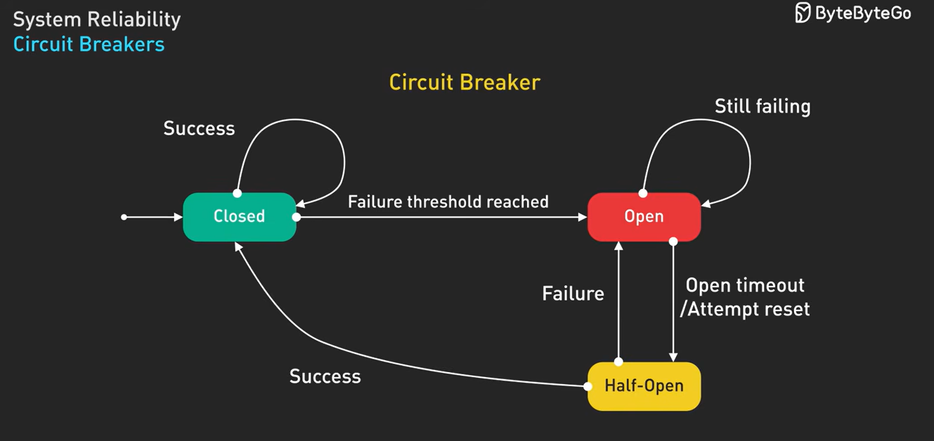

Rate limiting –

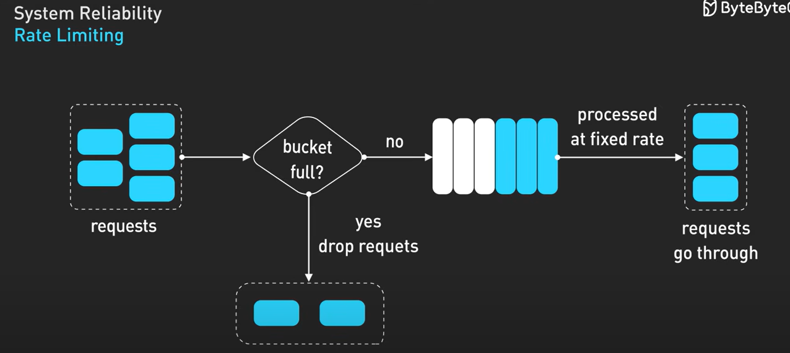

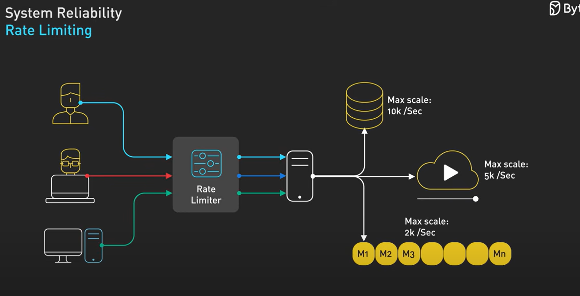

Monitoring – metrics, logs, traces, events.

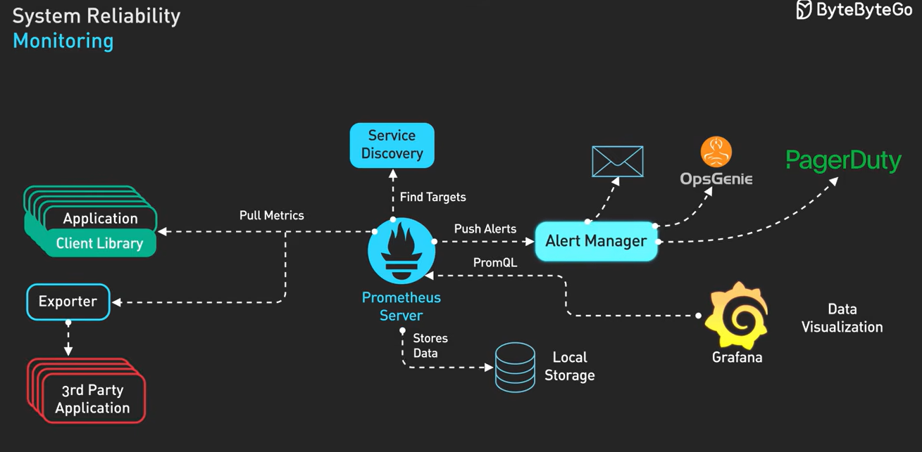

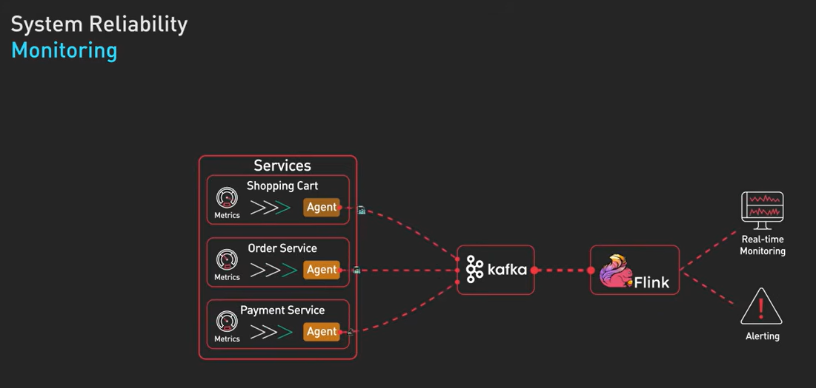

What is Kubernetes – manages deployments, scaling and management of a containerized application.

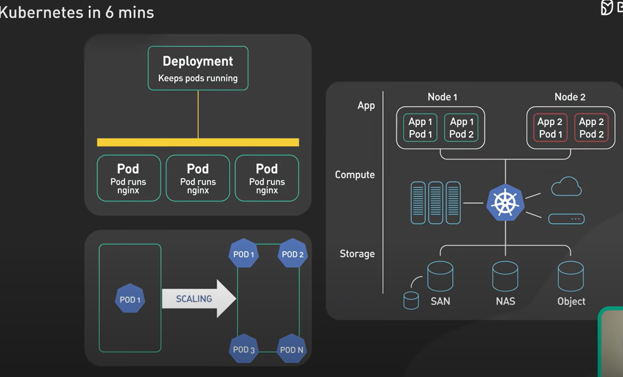

A Kubernetes cluster is a set of machines called nodes –

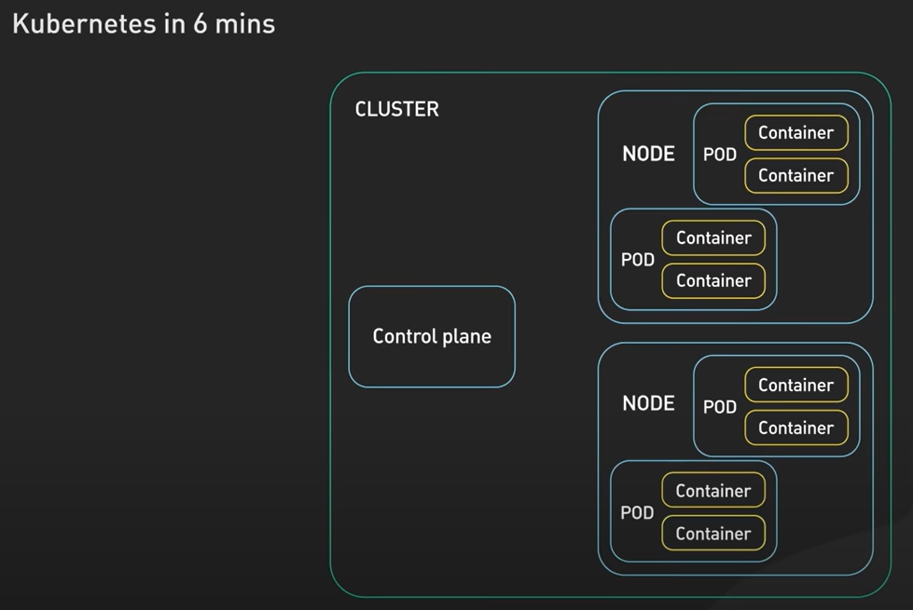

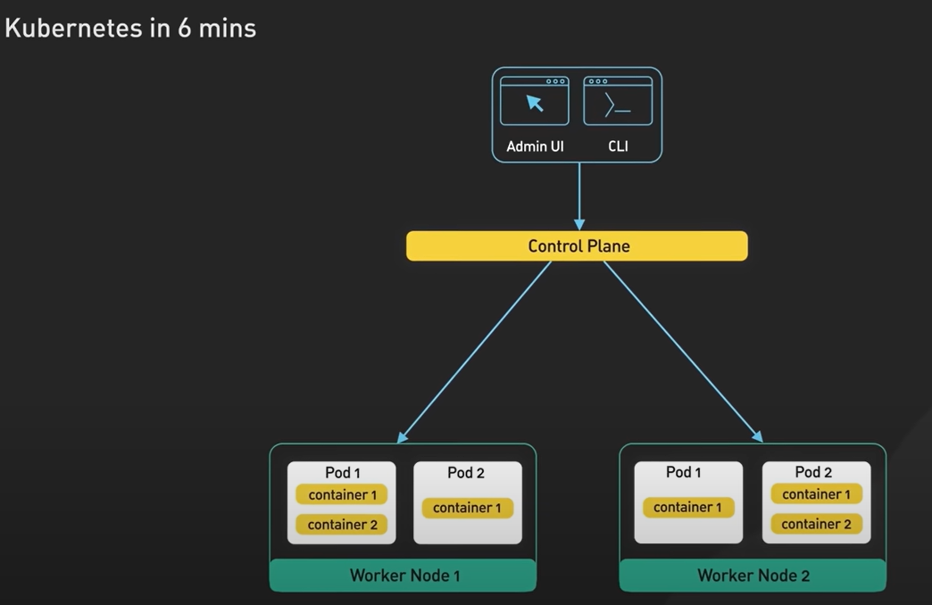

Pod provides shared storage and networking to the containers. Pods are managed and controlled by control plane by Kubernetes.

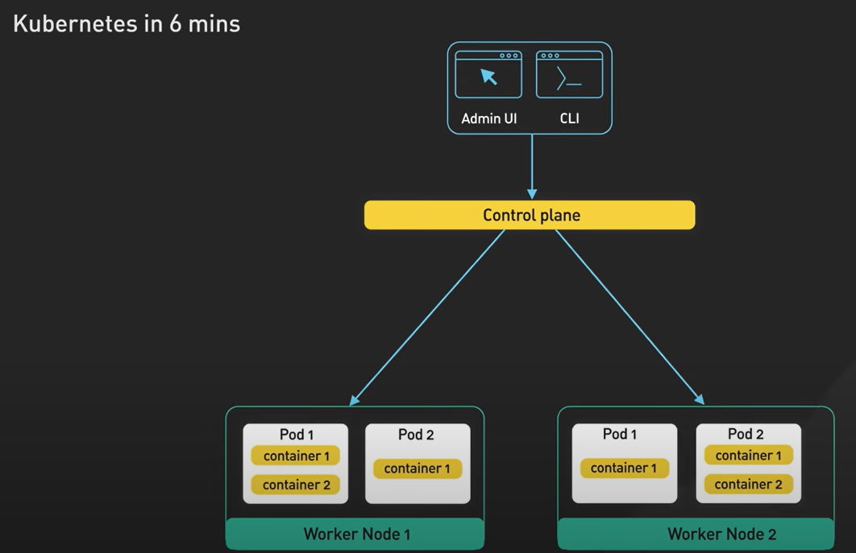

Control plane have controller manager, scheduler, etcd and API server.

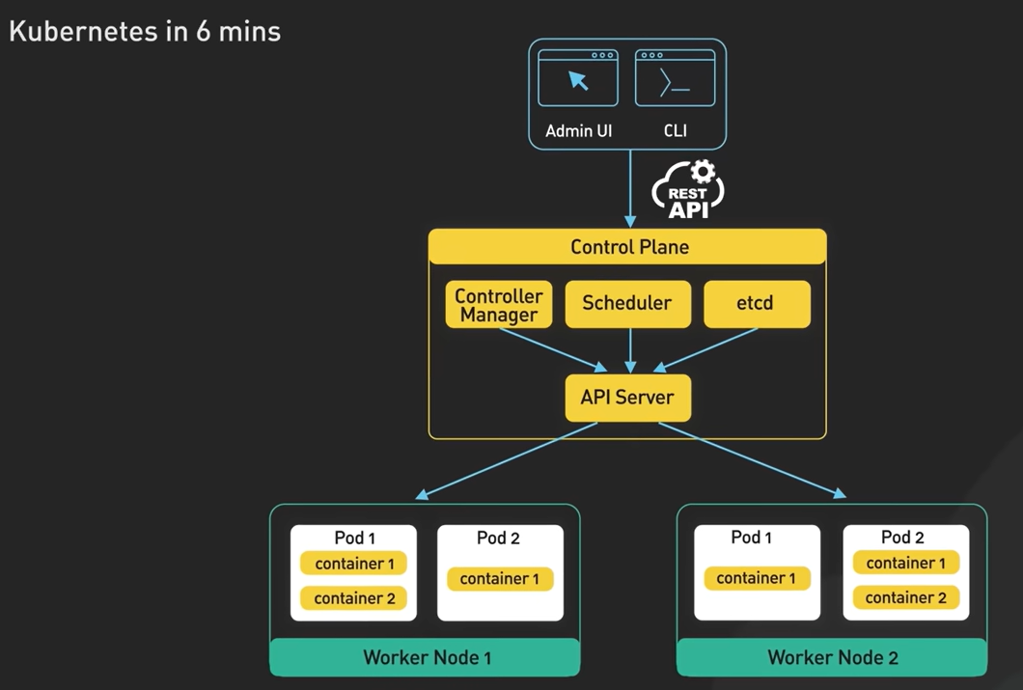

The etcd used by others to store and retrieve information –

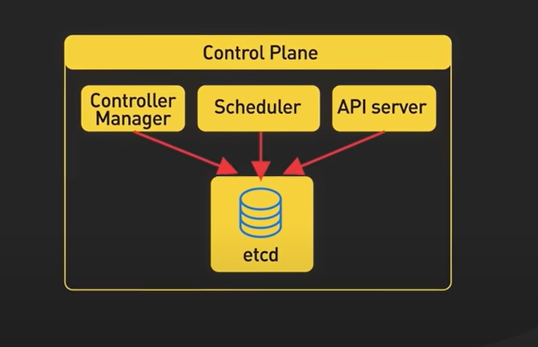

Main components of the worker node – container runtime (retrieve container from registery, starting/stopping the container), kubelet (talk with control plane and pod) and kube-proxy (networking, routine to pod and load balancer for pods).

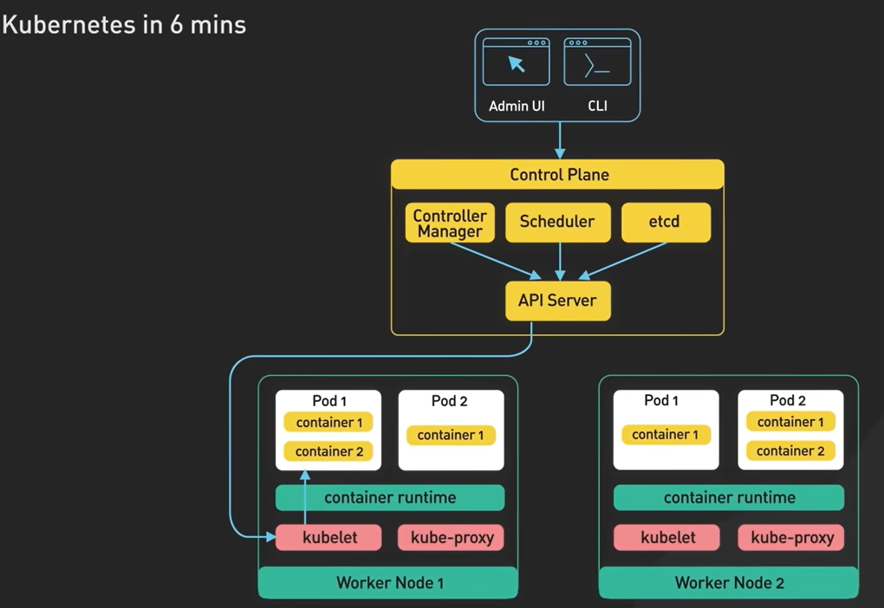

<https://www.youtube.com/watch?v=TlHvYWVUZyc>

Features of Kubernetes –

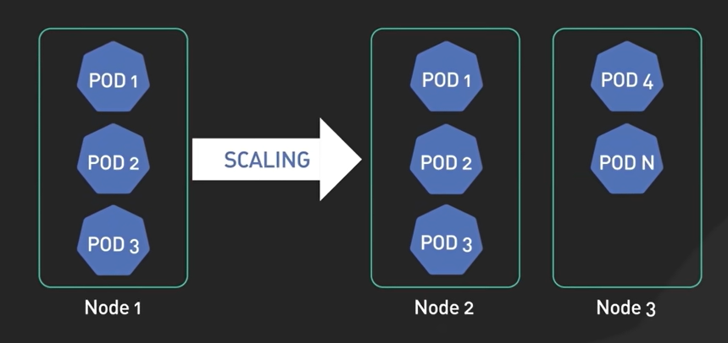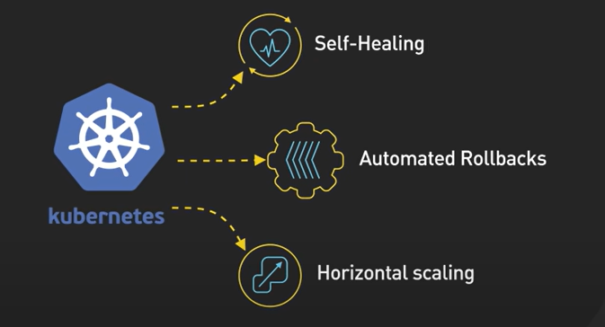

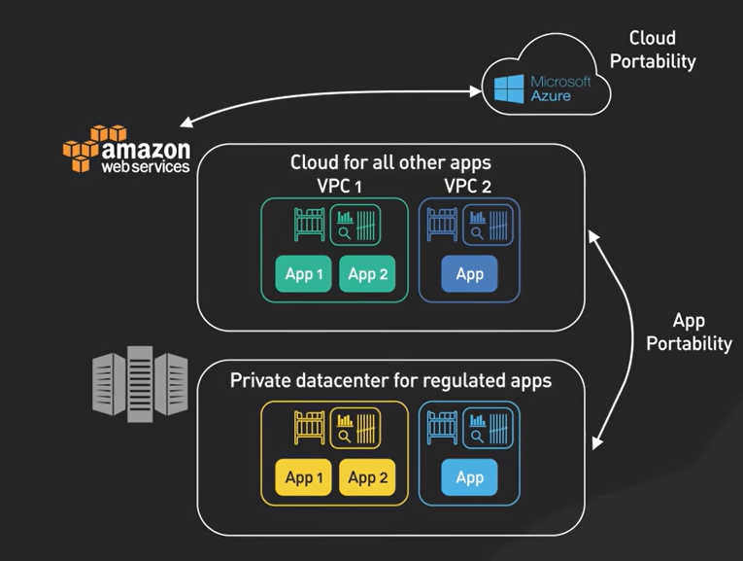

Kubernetes – complexity due to distributed system, initial cost is high. For cheap we can use managed Kubernetes service from AWS.

Top 6 most popular API architecture styles –

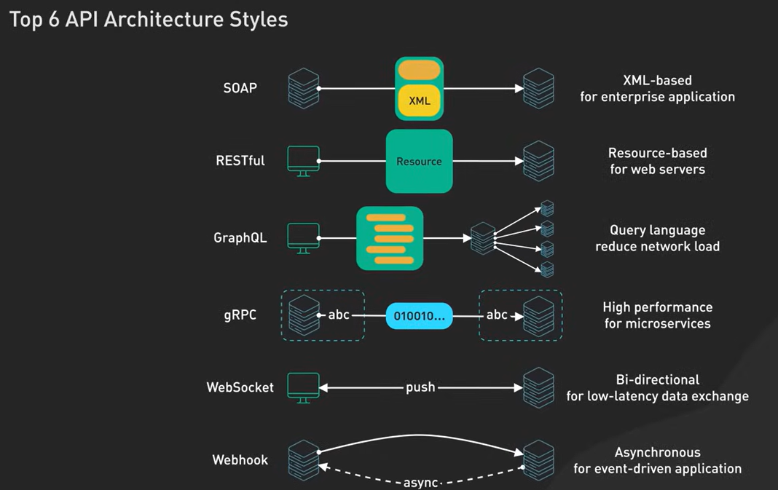

Soap is mostly used in financial service and banks for security but might be overkill for a mobile app as it is very verbose.

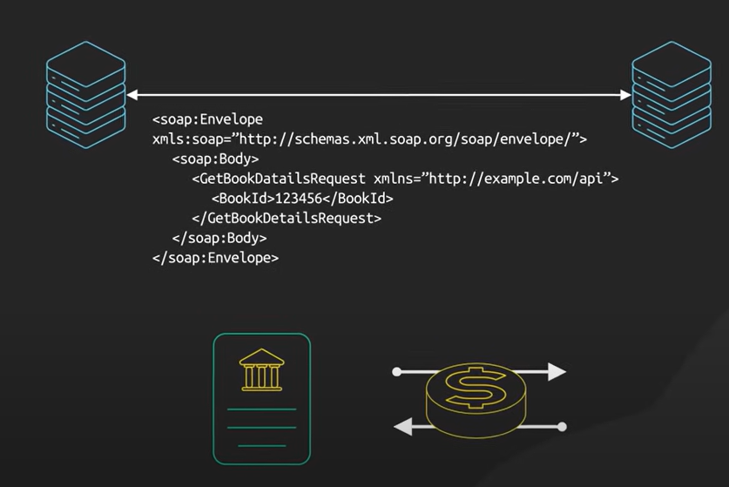

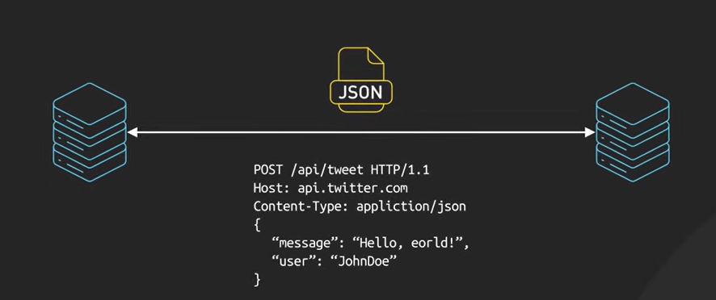

But REST is not suitable for highly connected data model for real time updates.

GraphQL allows client to ask specific data as they need to avoid over fetching and under fetching of data which makes is very fast and efficient and useful for apps which have complex data requirements . it has steep learning curve, require more processing at server side –

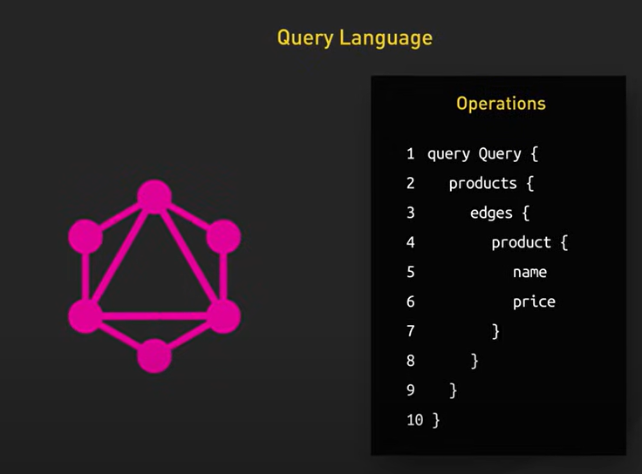

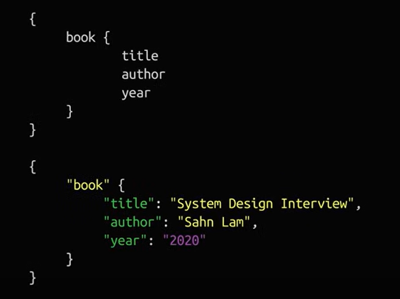

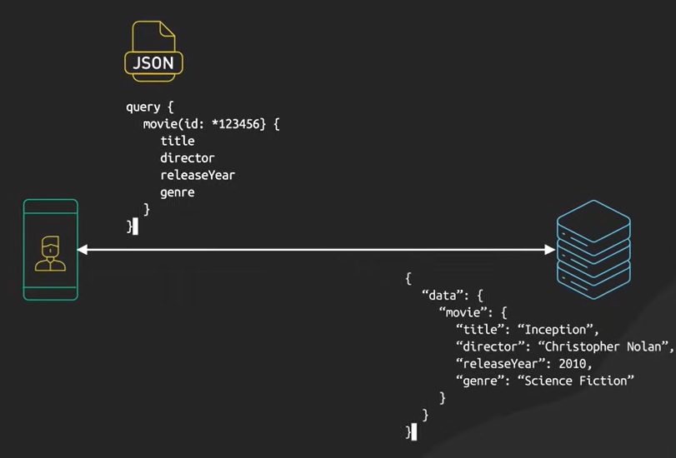

gRPC – use protocol buffer, useful for microservices architecture but have limited browser support –

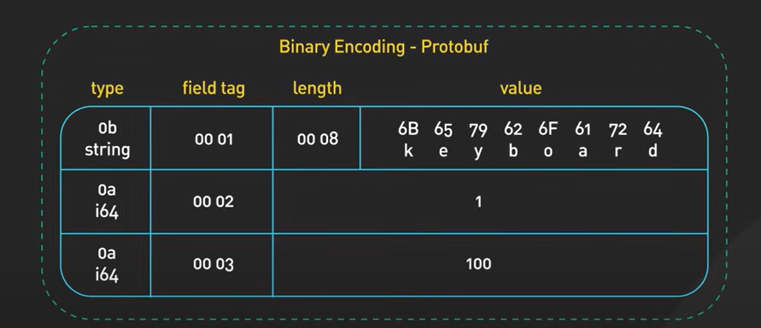

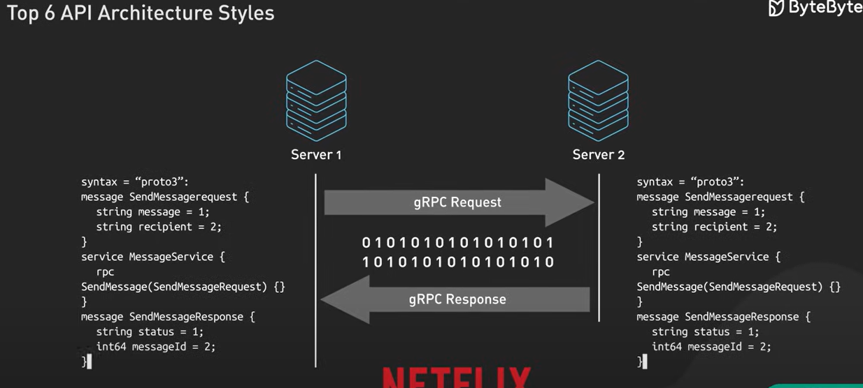

WebSocket is ideal for live chat application and gaming for low latency data exchange -

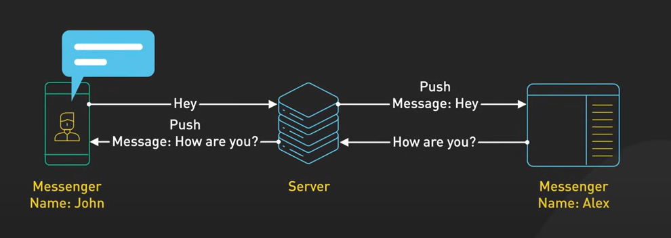

Webhook – event driven –

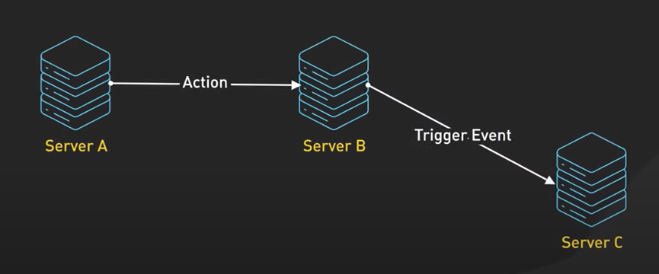

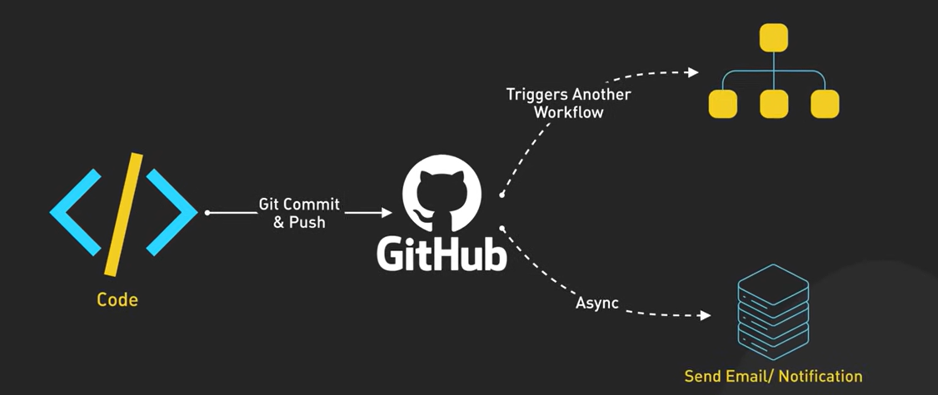

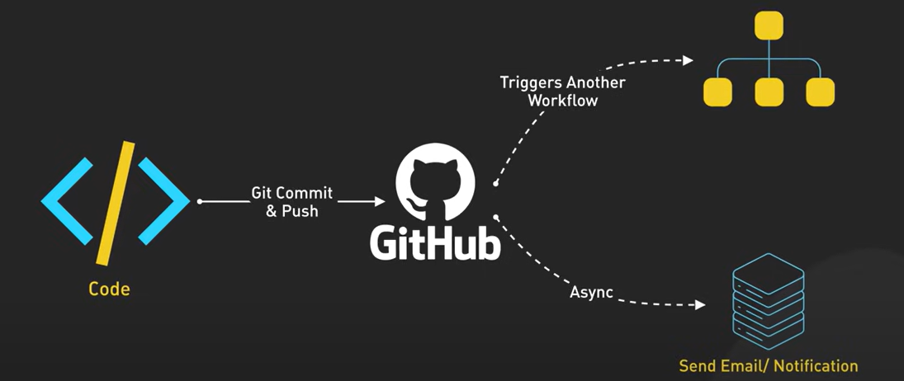

Webhook might be best fit if we need synchronous response.

# VS Code: Productivity and Customization

We can filter the extensions by category –

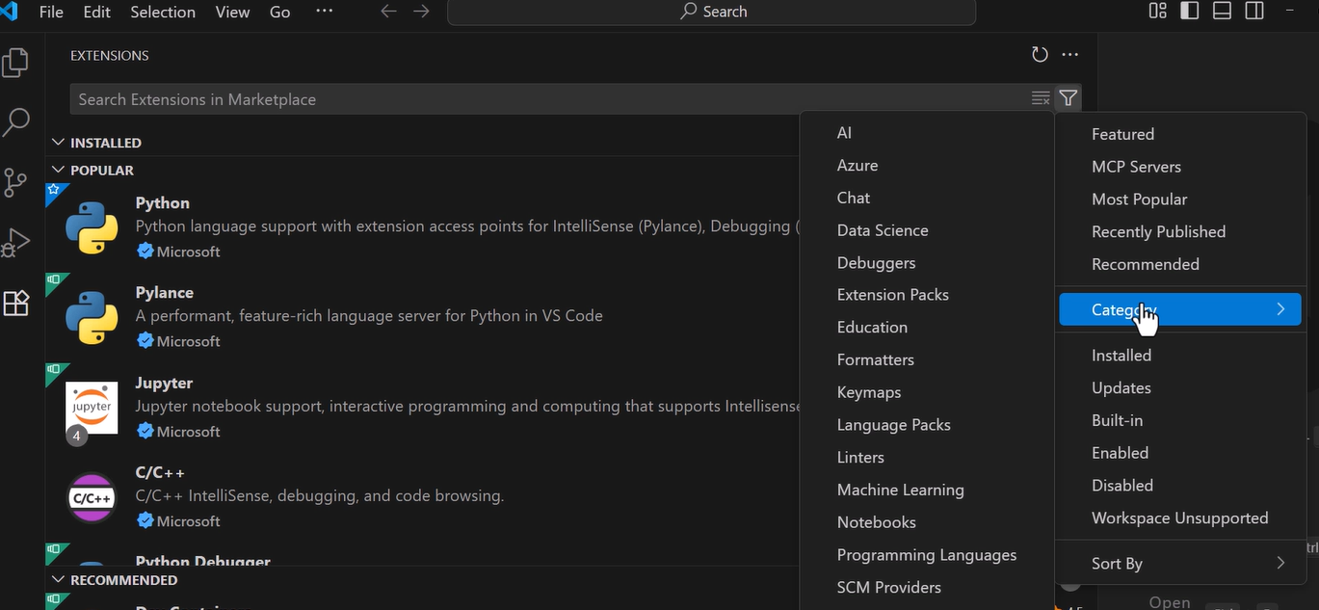

We can search the extensions based on the publisher, category and tags –

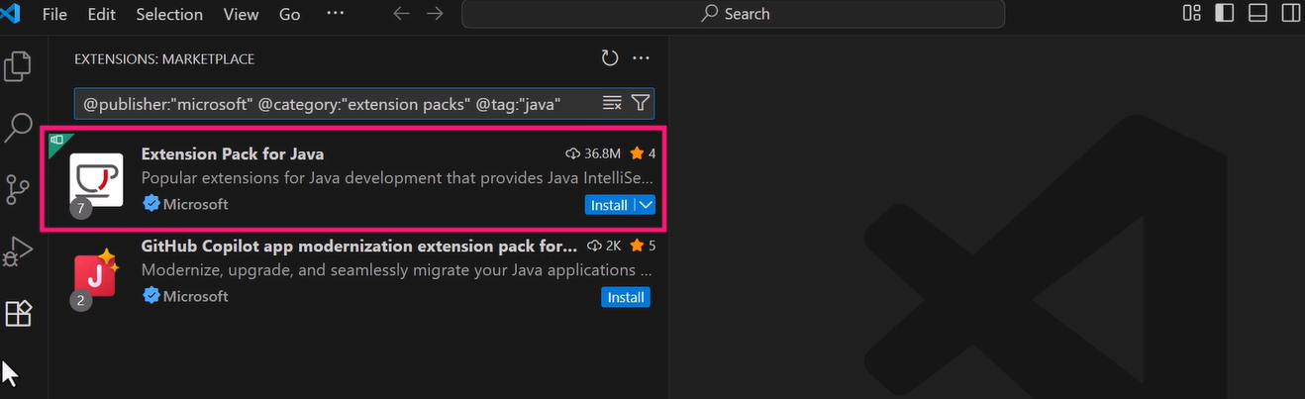

# VS Code Foundations

Timeline view for files.

We can use features like ascending lines for sorting.

Using Regex expression –

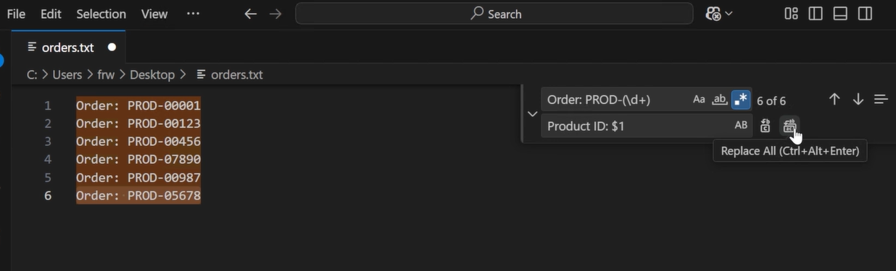

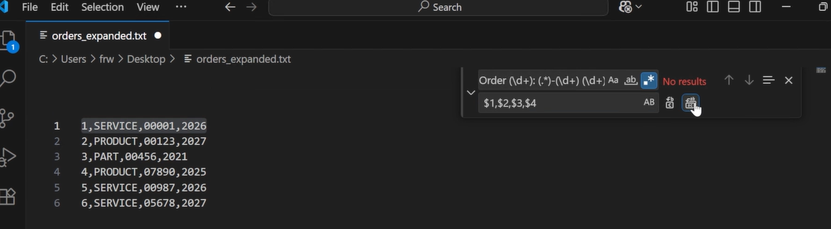

It also provide remote window to connect with file on remote location –

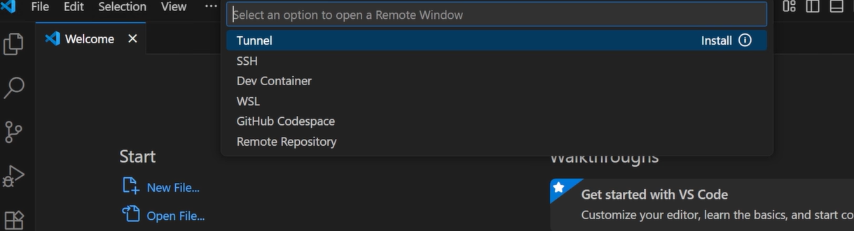

We can use the Live Share extension to share our screen –

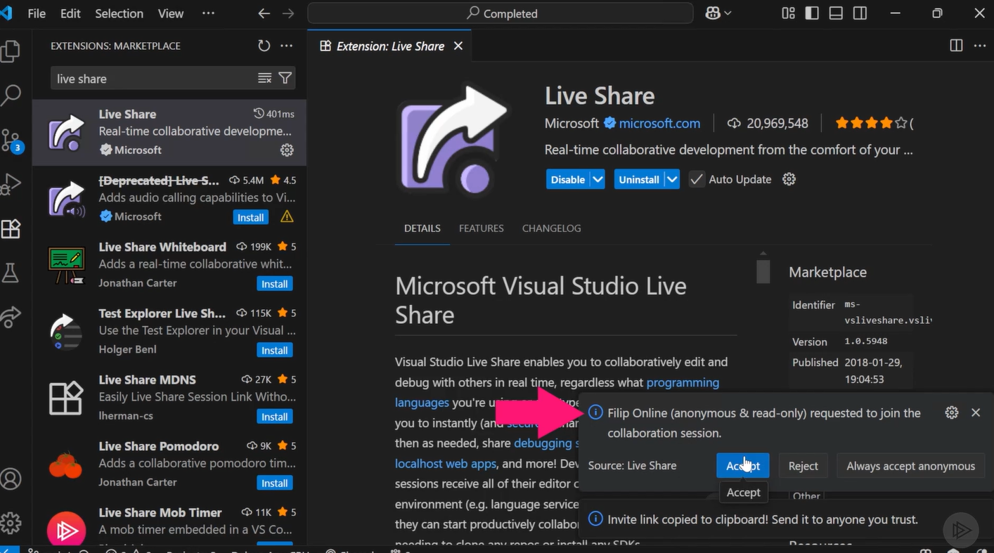

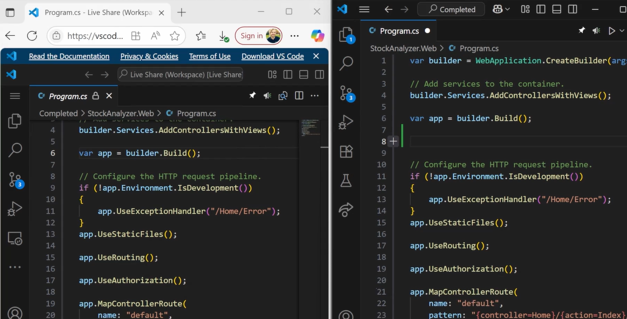

# How Does a URL Shortener Work?

Approach one using MD5 hashing –

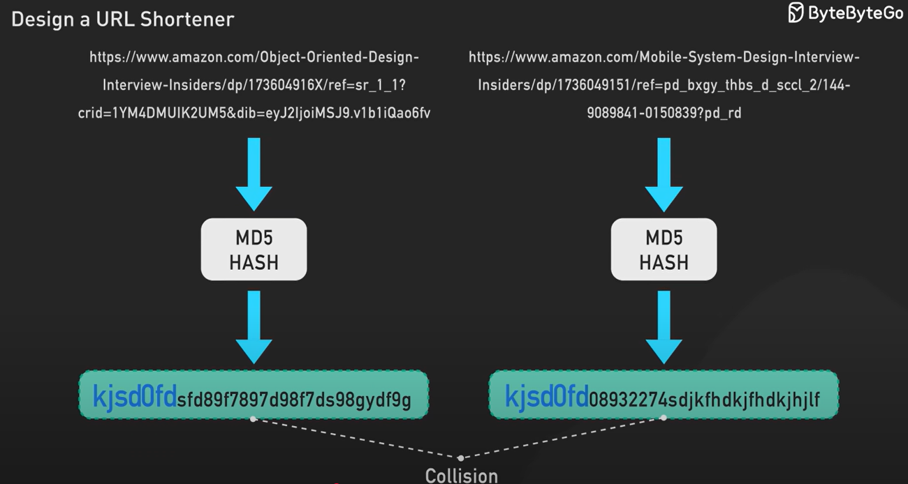

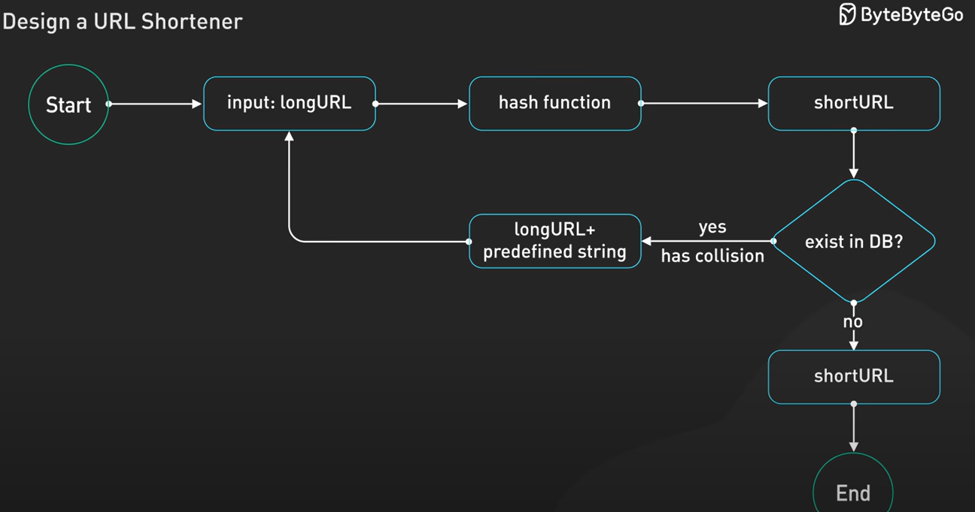

Approach two using reminder on sequence number –

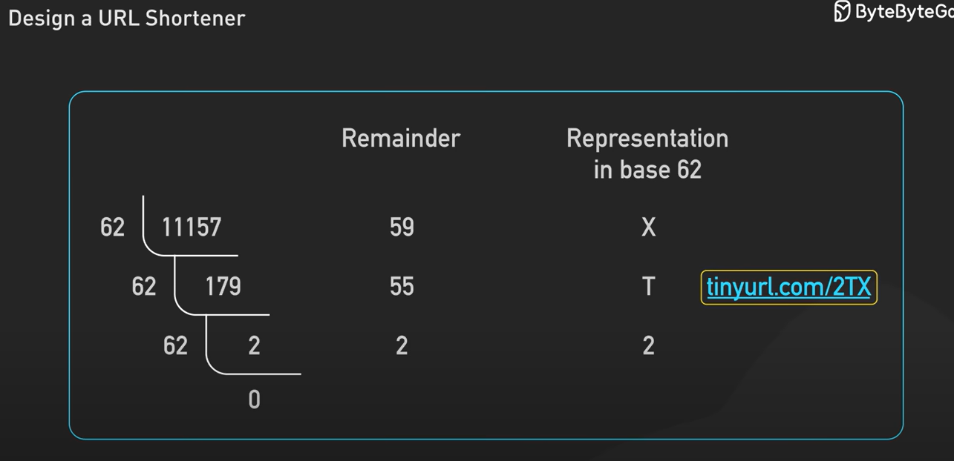

We will return status code 301 permanently moved so that next time the browser will directly redirect the use to the long URL.

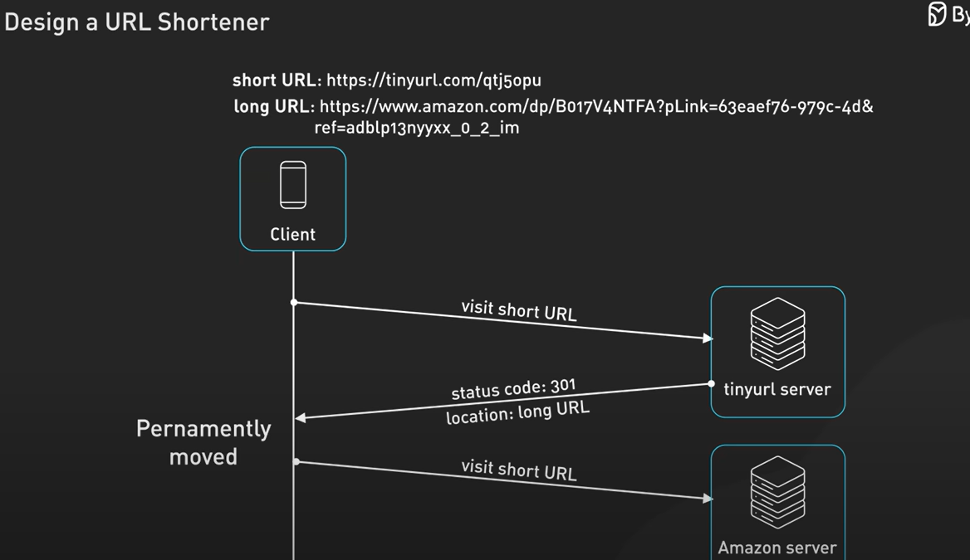

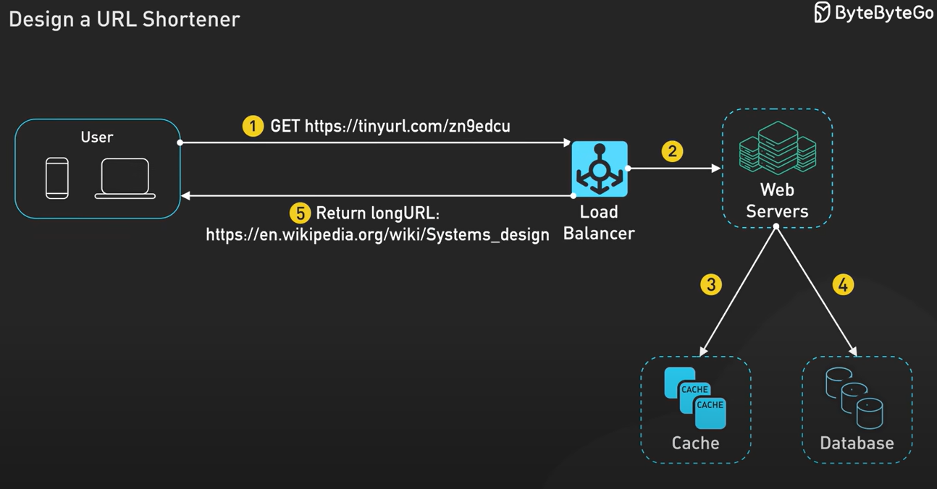

# System Design Interview – BIGGEST Mistakes to Avoid

Not just solution but ability to communicate and collaborate, don’t work silently. Like pull or push based approaches, each limitations and advantages, ask for feedbacks.

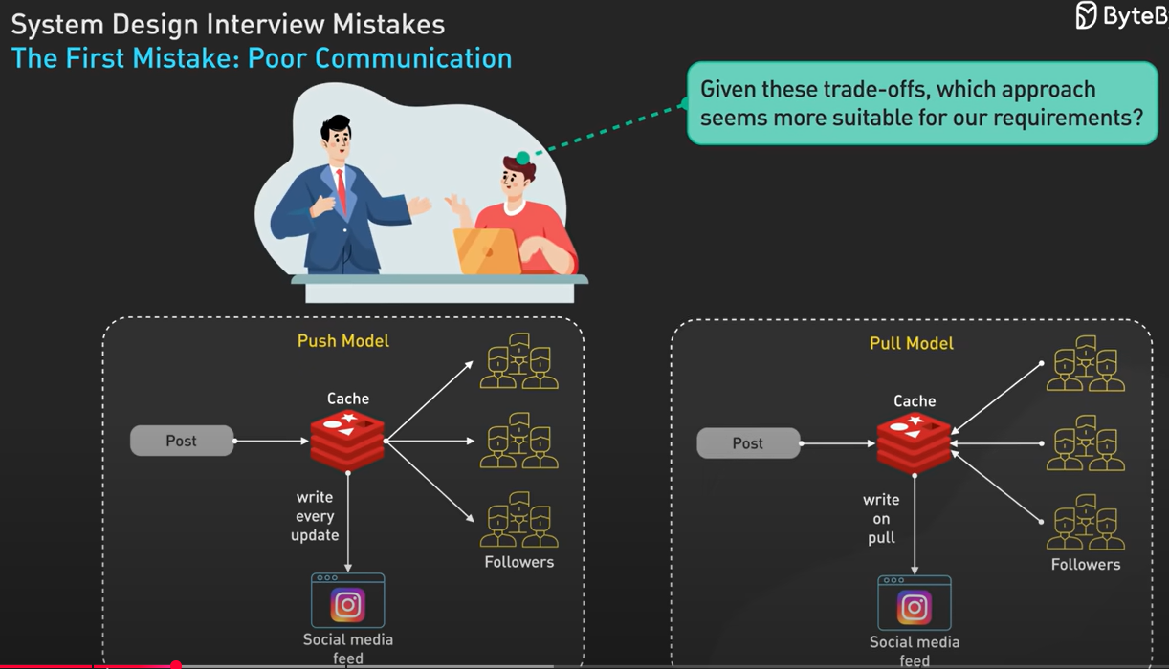

Don’t jump to solution too soon, ask requirements first, start with questions first. Ask for functional and non-functional requirements. Tell me your assumptions.

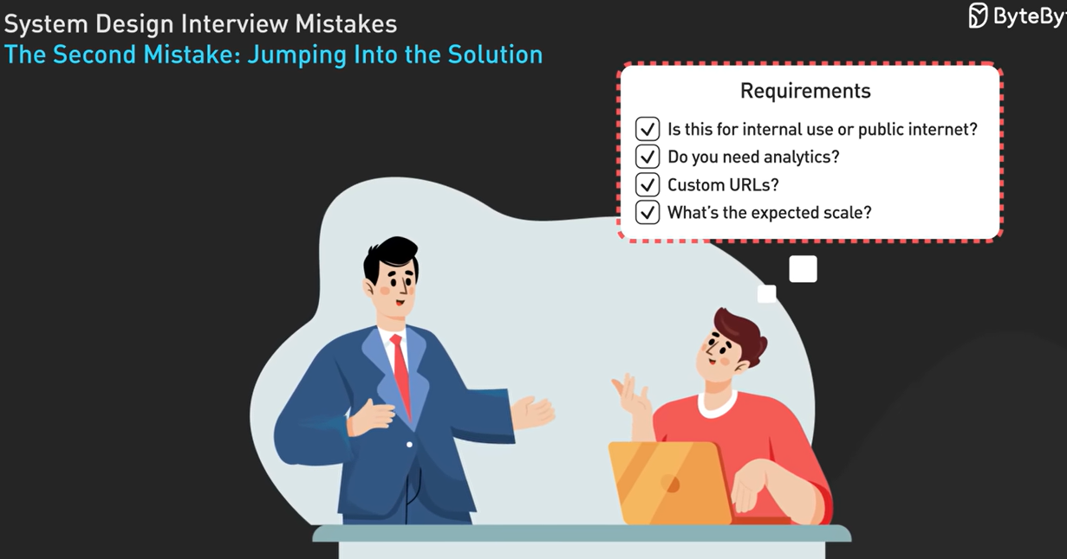

Start with big picture and major components not implementation related details directly.

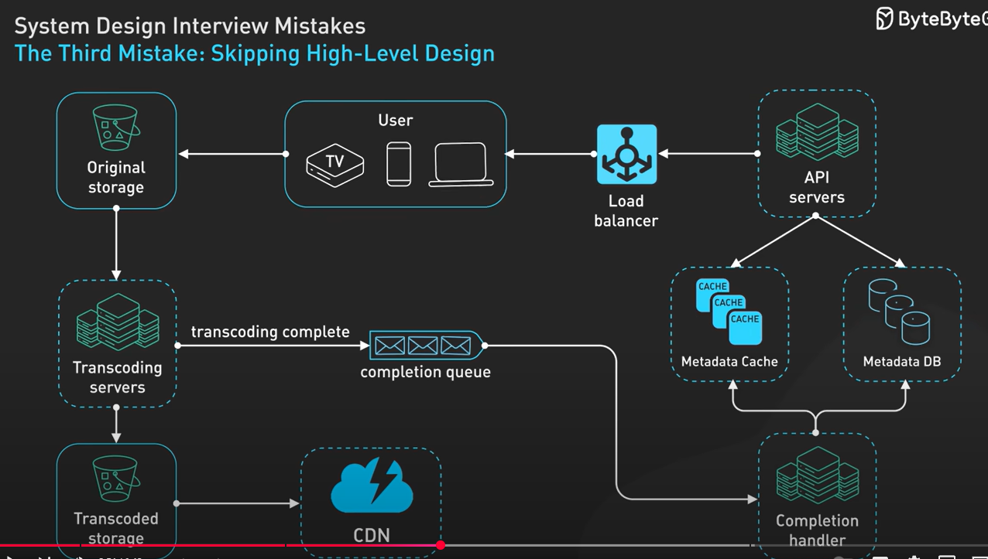

Walk through the flow –

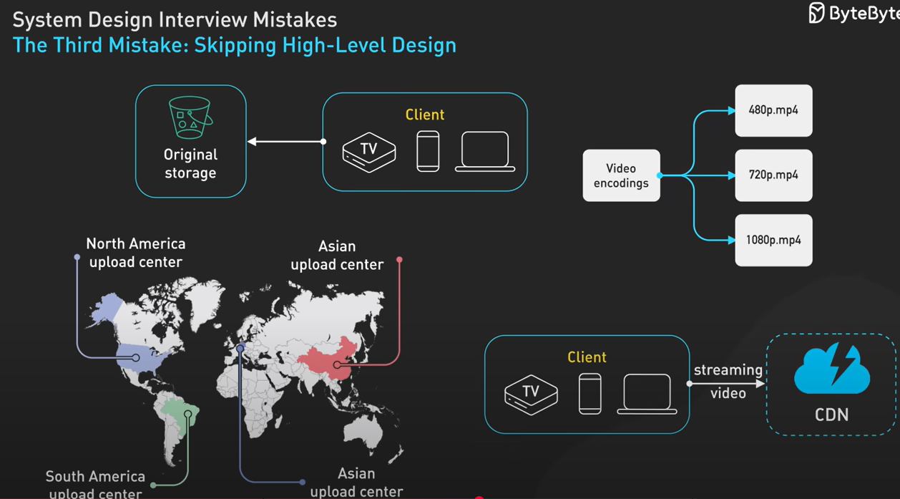

Then dive into specific components –

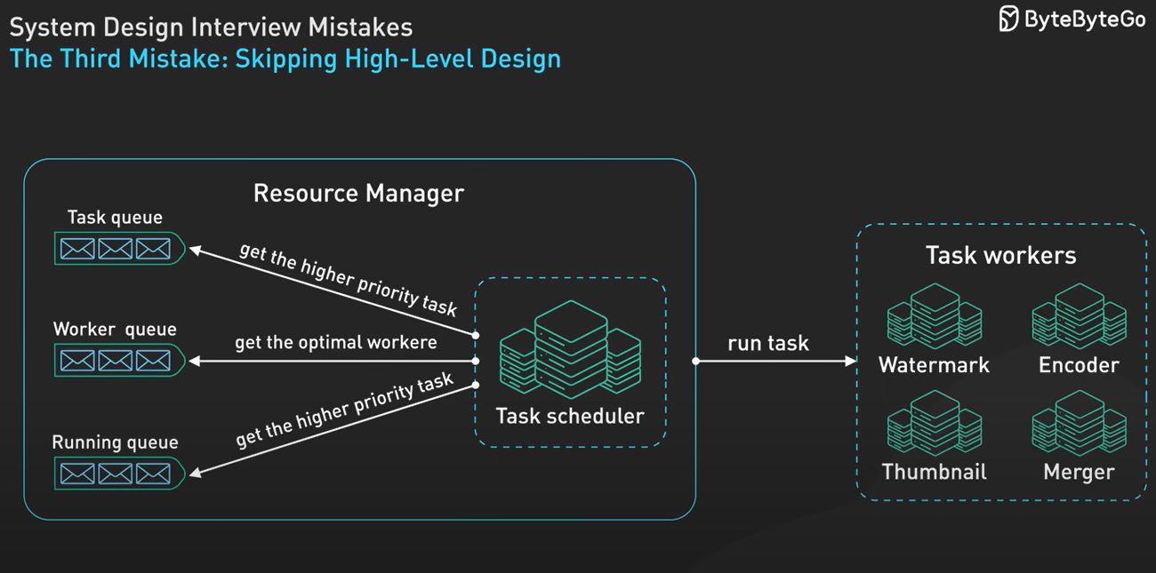

Tell trade off with different approaches and give recommendations –

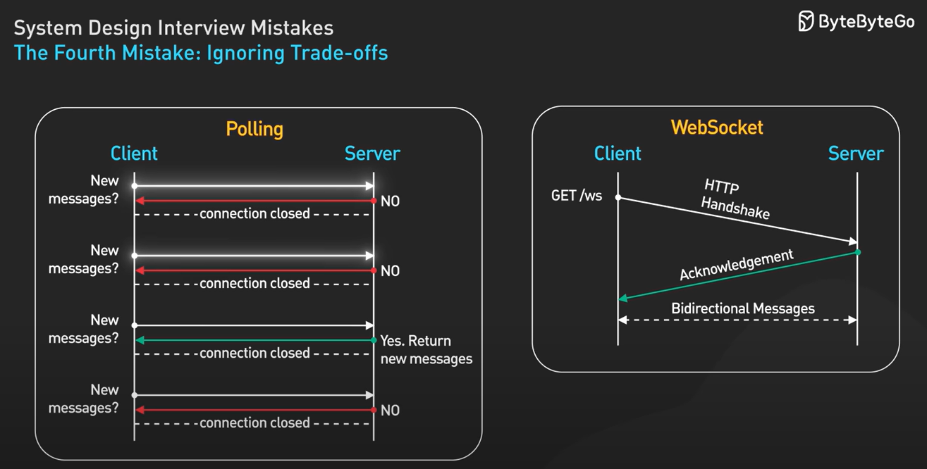

Start simple then scale if needed to avoid early optimization.

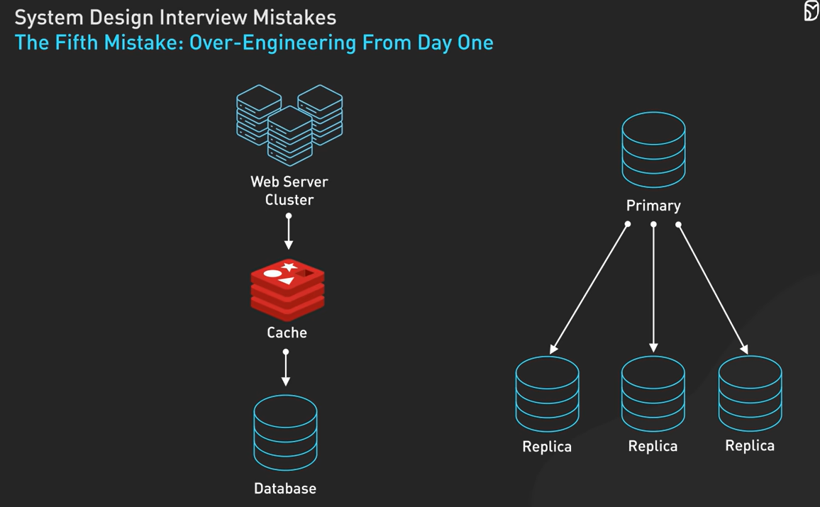

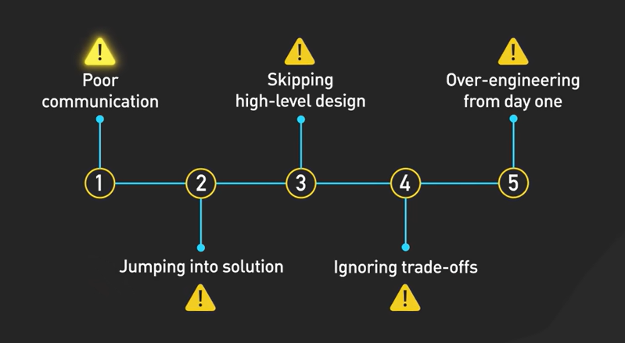

# 20 System Design Concepts You Must Know - Final Part

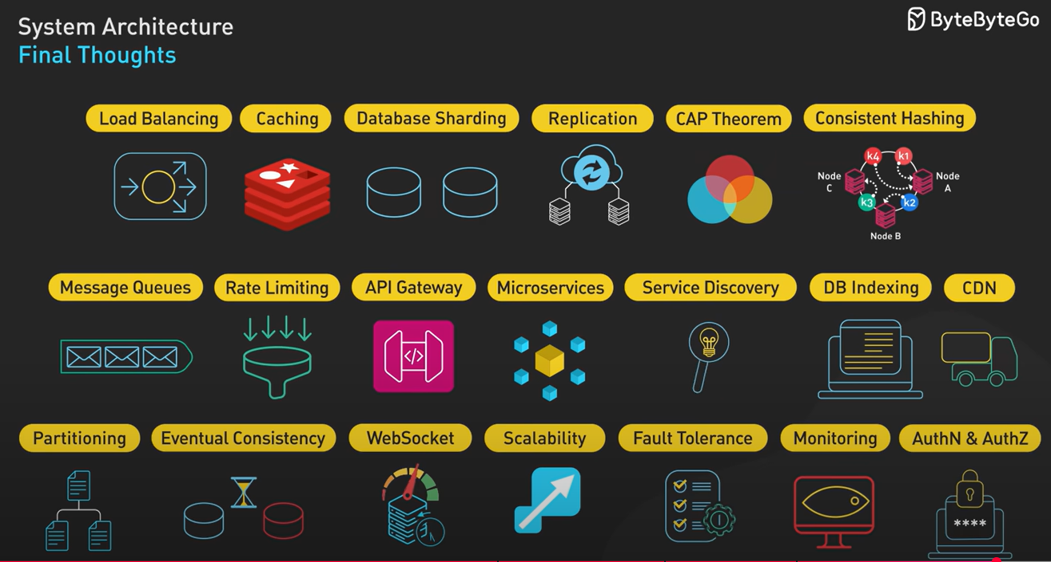

Microservices –

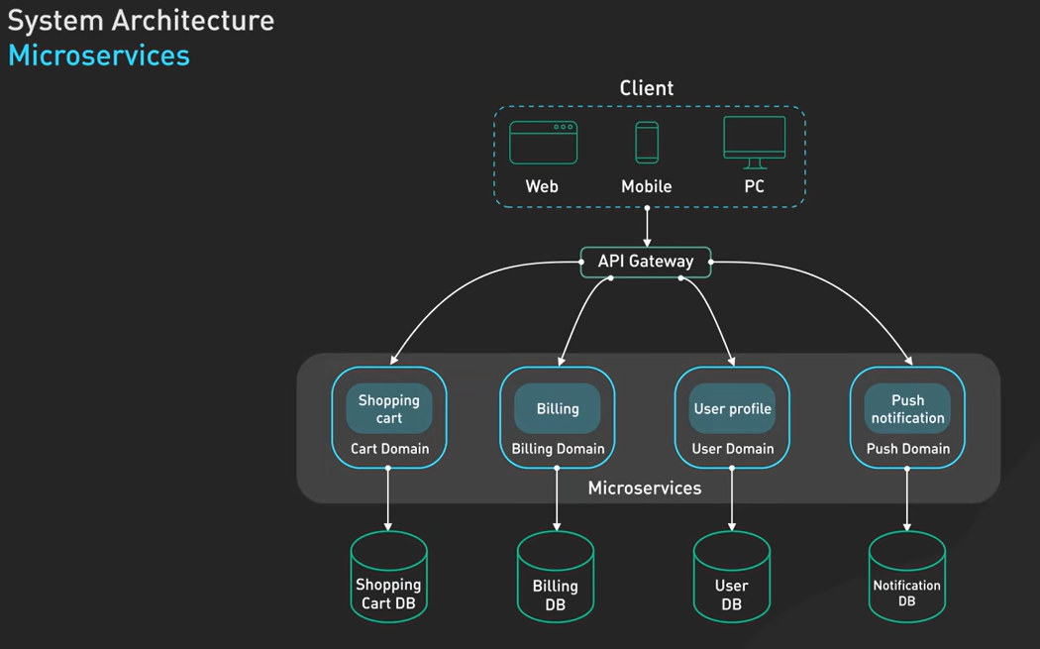

By using microservices, teams can work independently, can use various technologies as suited and it can expand individually. But introduce complexity, not for small team.

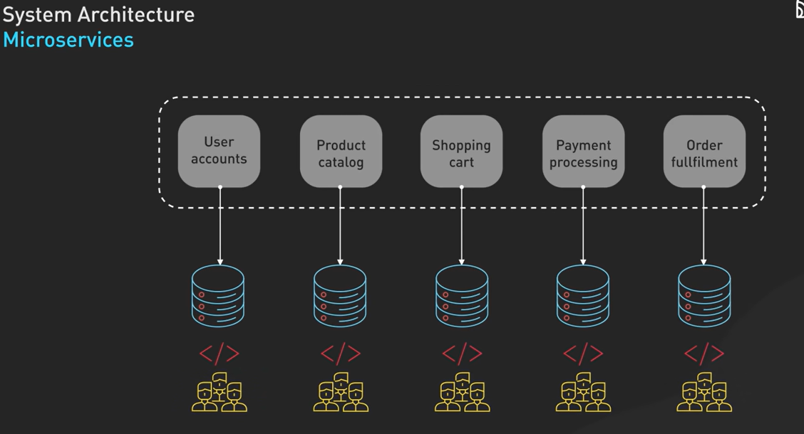

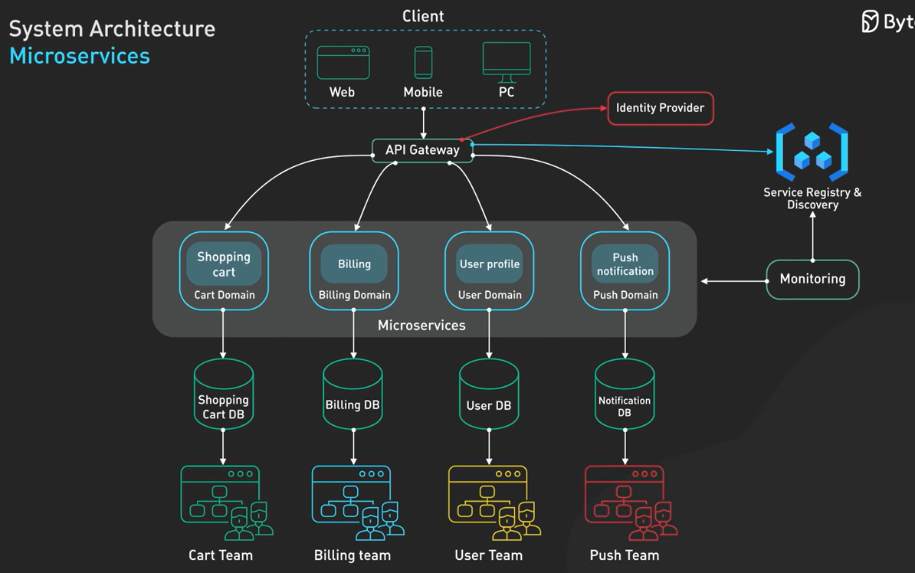

Authentication and Authorization –

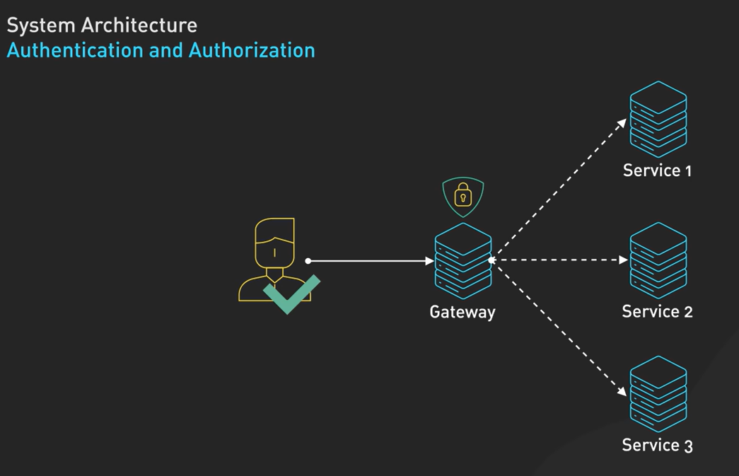

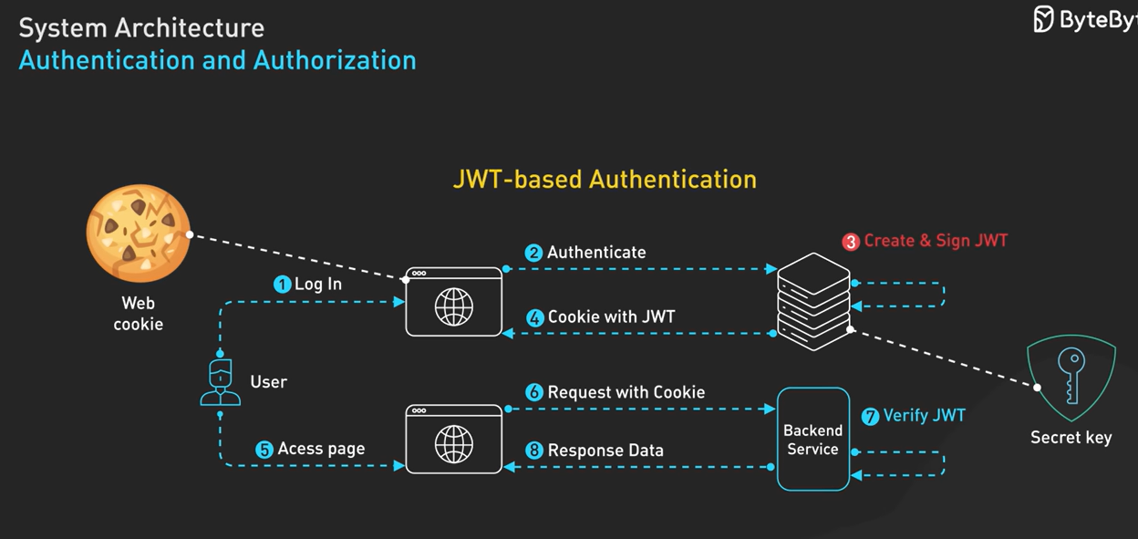

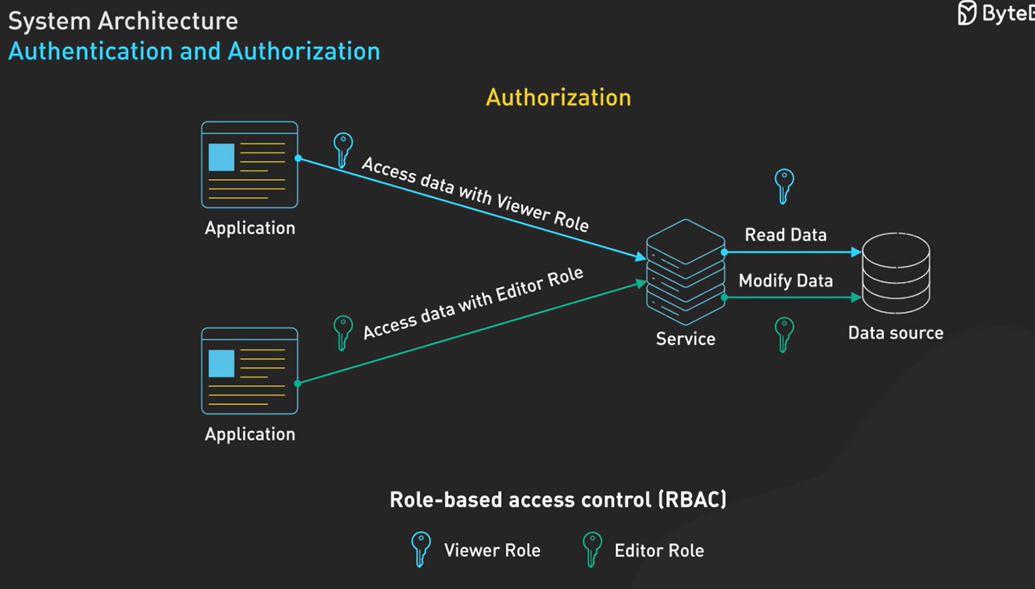

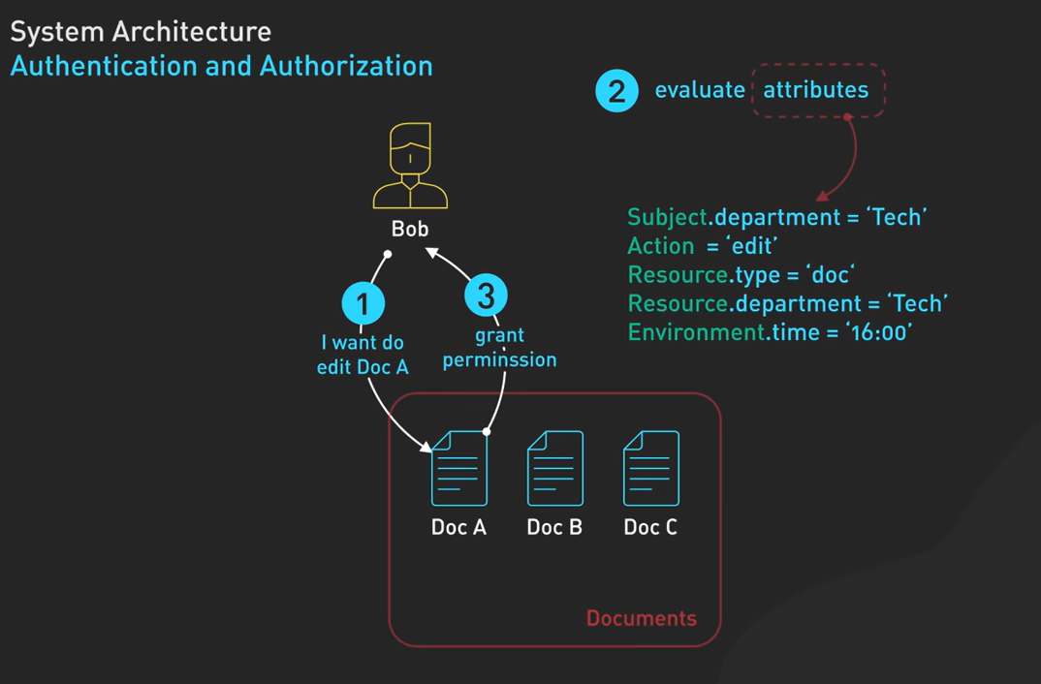

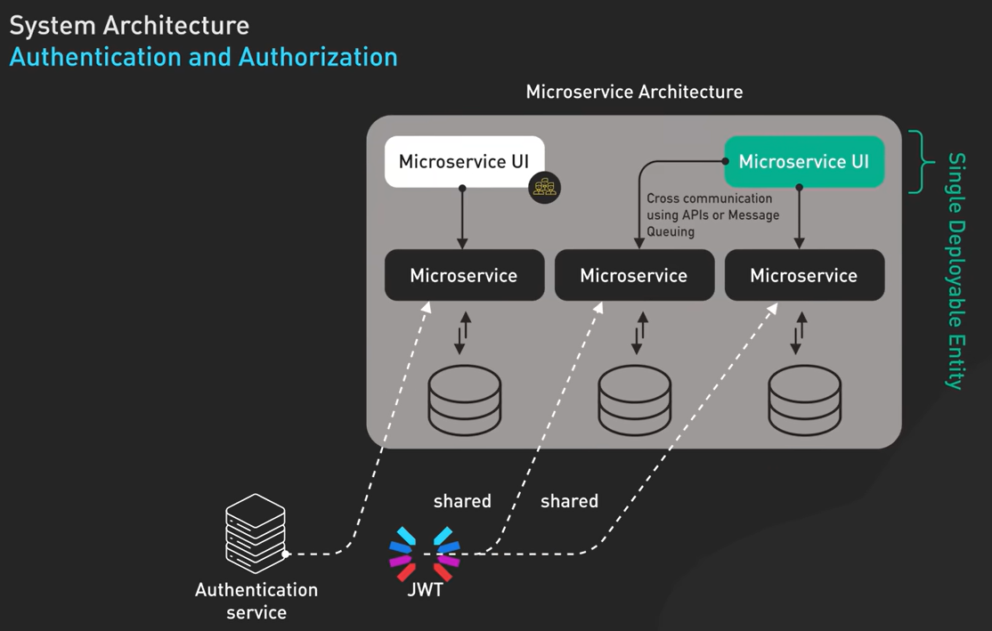

Service Discovery –

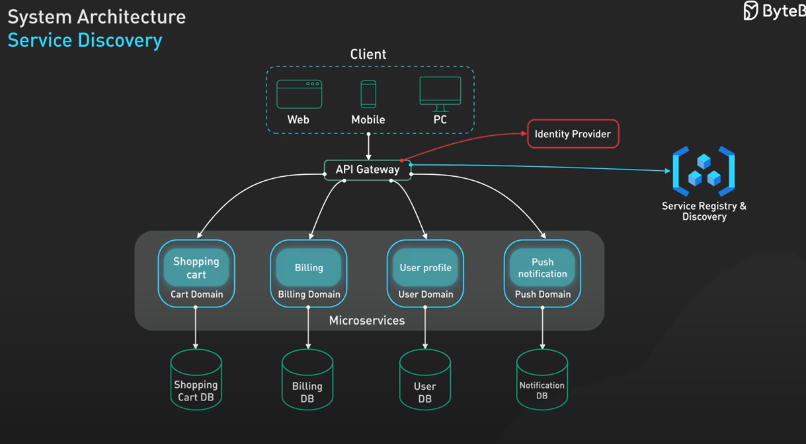

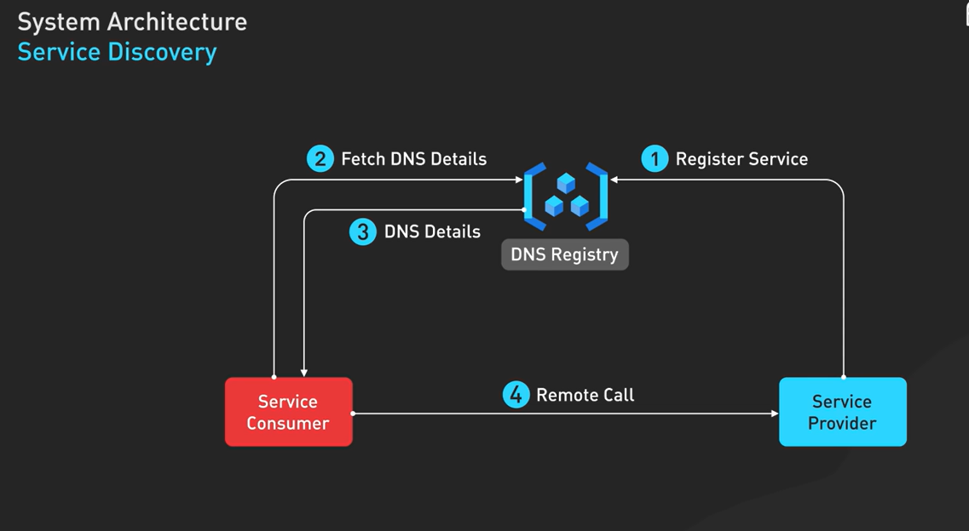

API Gateway – avoid tight coupling and enable system to evolve. Handle rate limiting. Providing unified interface.

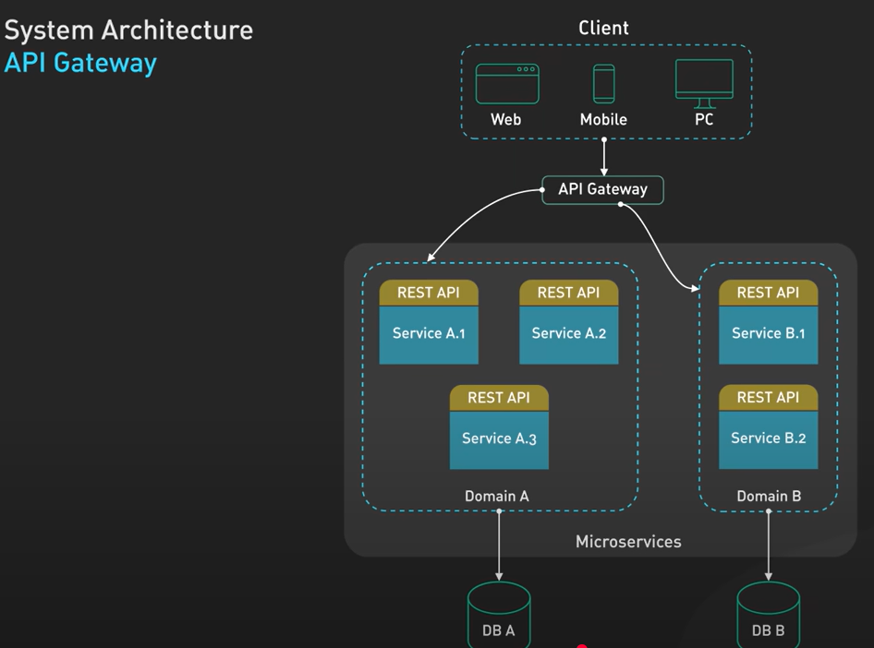

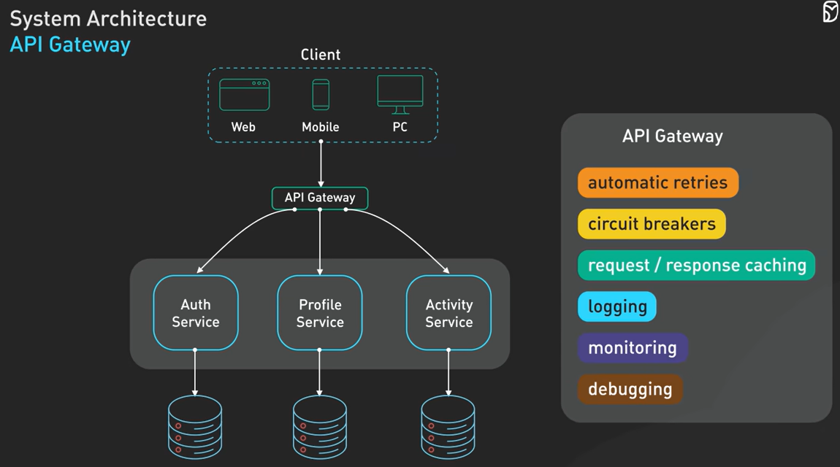

Message Queues – provides sync communications between component without need to both components need simultaneously available at the same time.

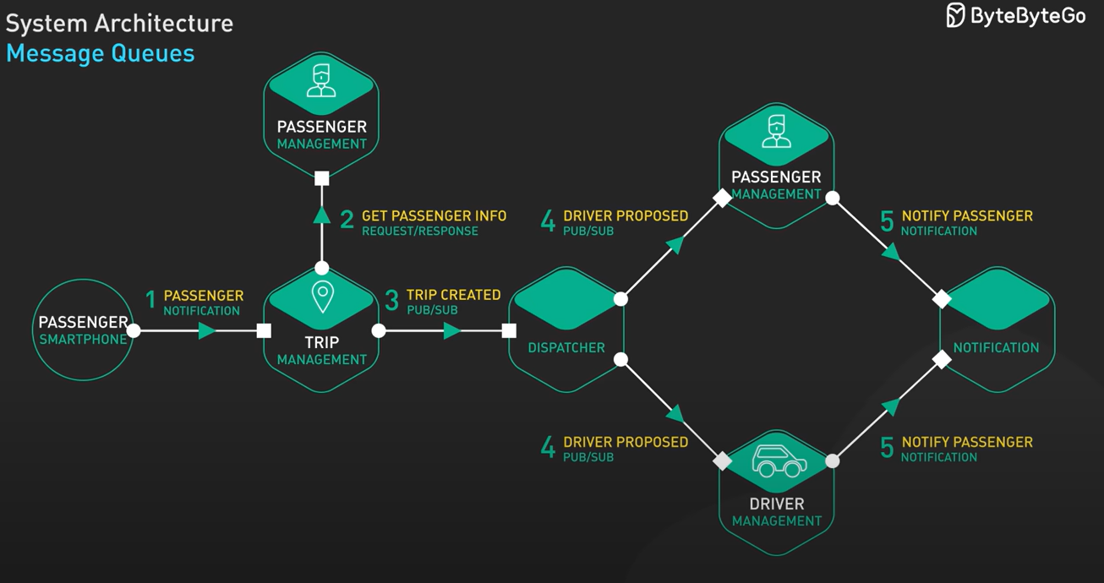

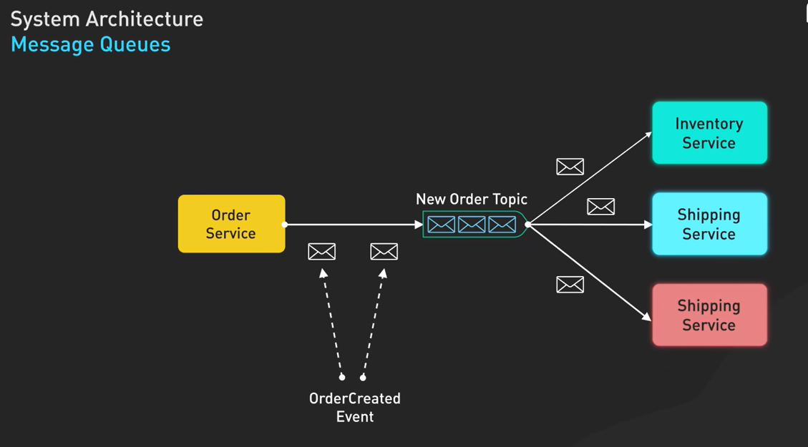

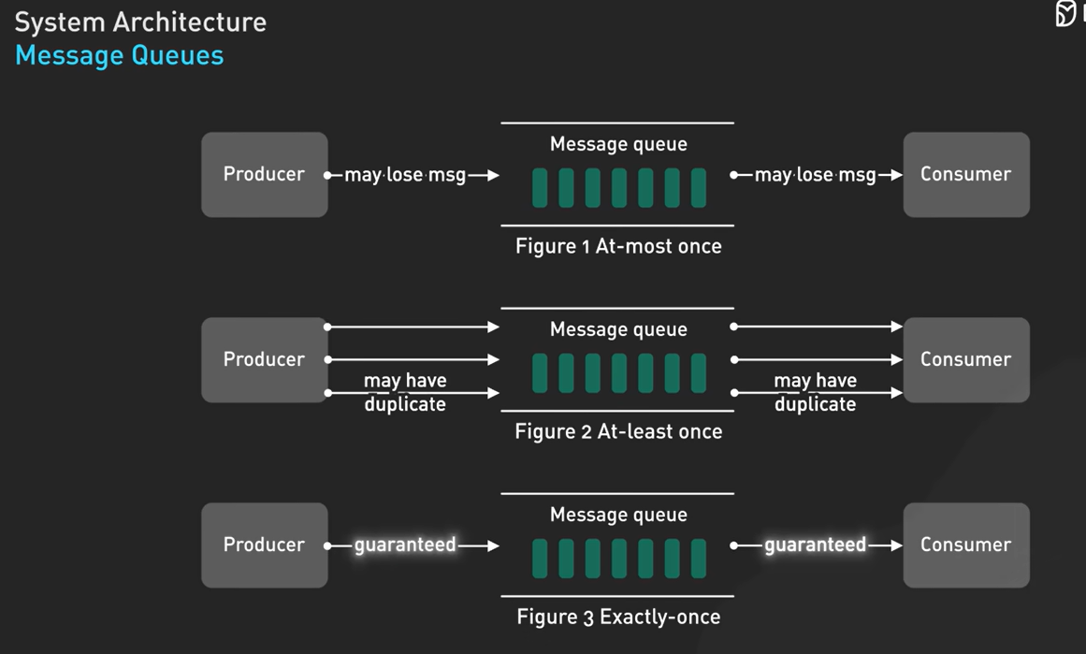

WebSocket – both client and server can send messages independently without waiting for pull request. Reduce latency, avoid server load as no pull request, but it introduce complexity and firewall and proxy server can interfere with the connection.

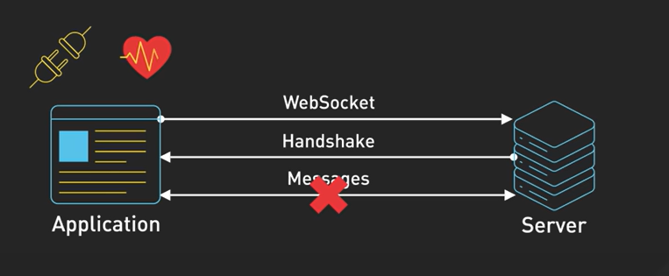

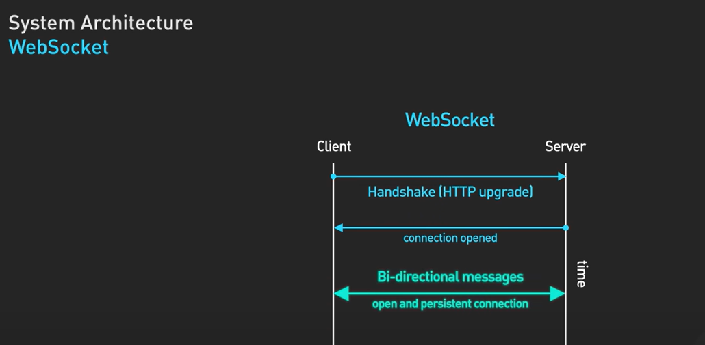

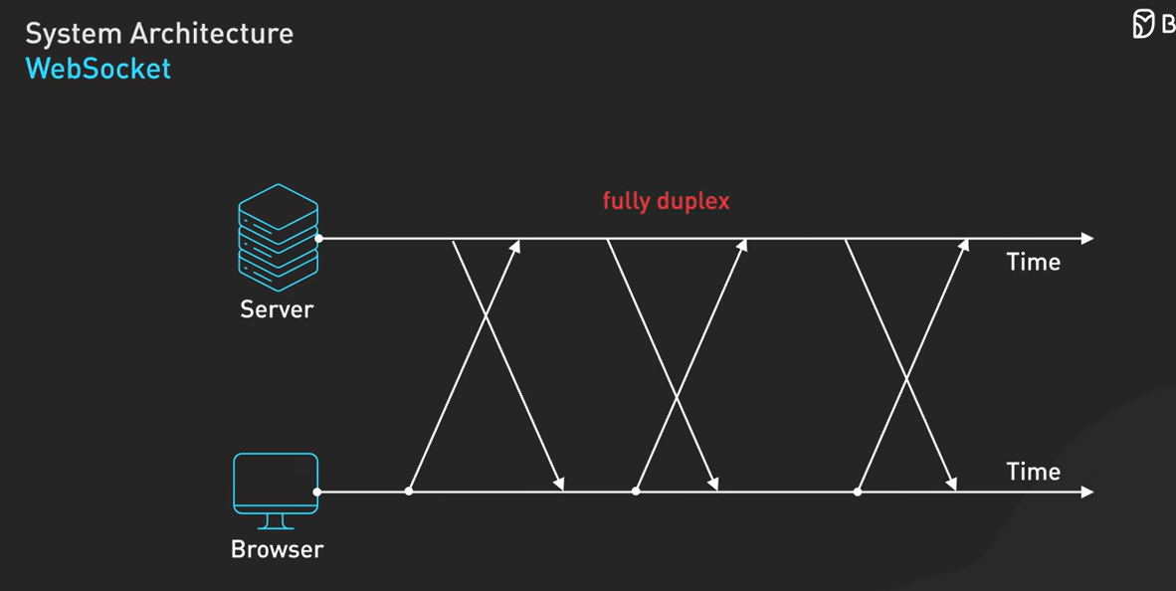

For scenario too much write operations use a message queue system, use cassandra –

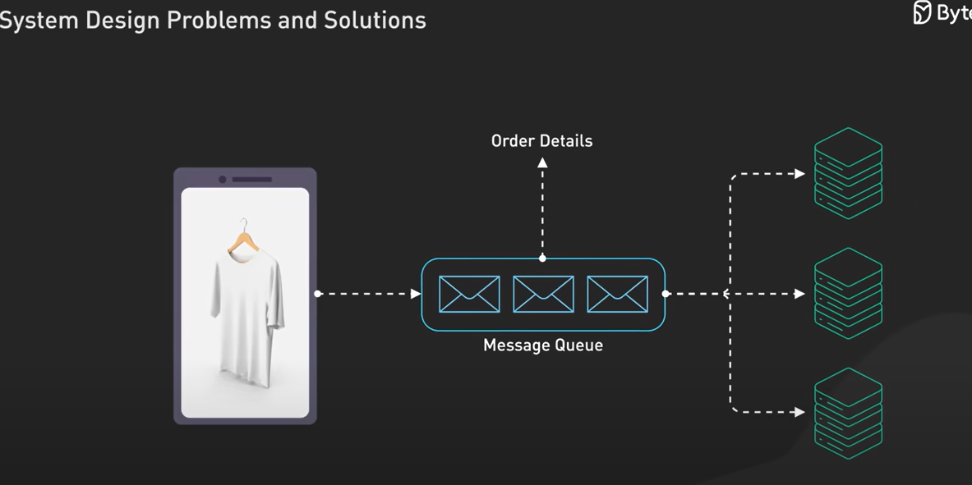

For scenario too many read operations use cache with concept of TTL, use redis.

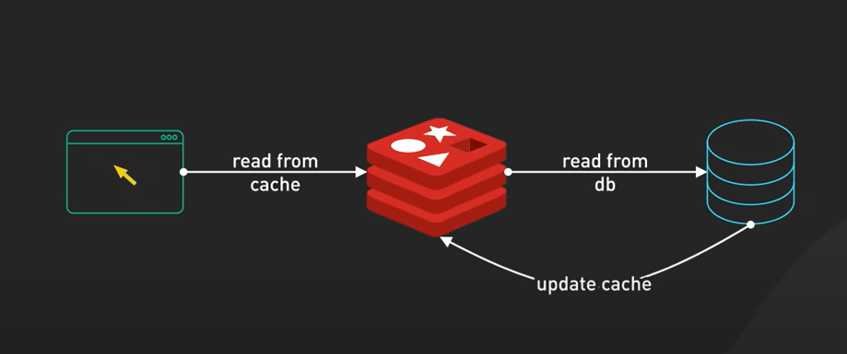

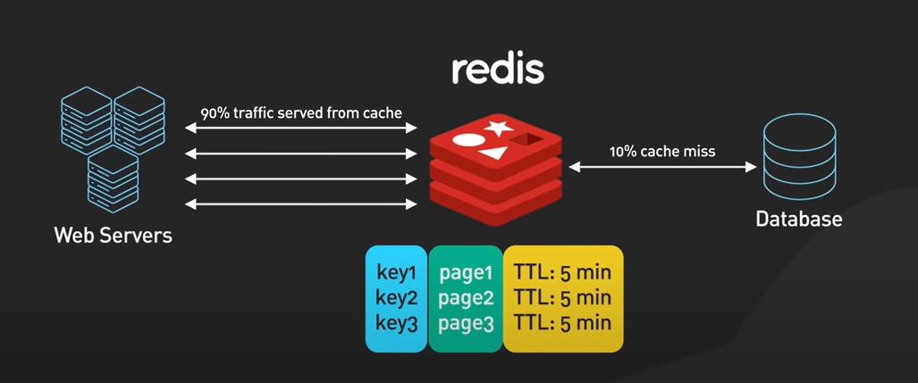

For scenario for avoiding system failure or database failure or data loss, use load balancer with replica in sync, primary and secondary node –

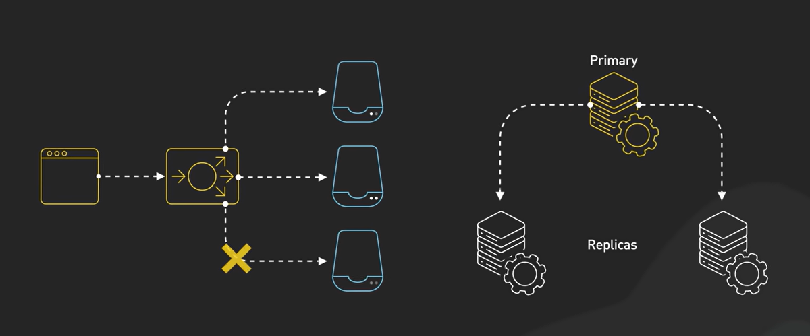

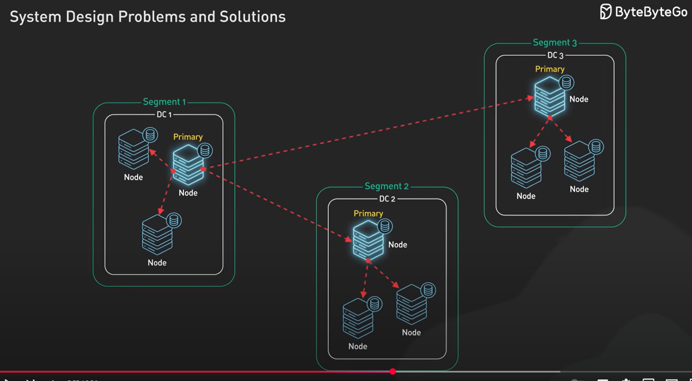

For scenario for performance use CDN to avoid latency –

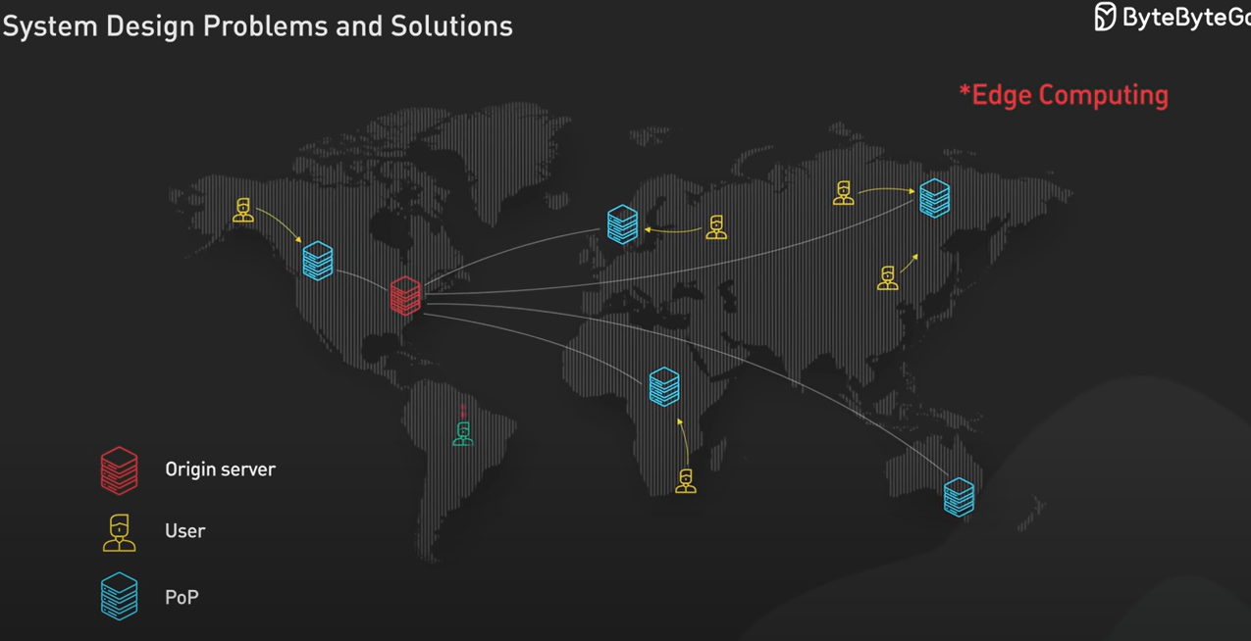

For scenario of managing large amount of data – block storage is good for database or small data files. Object storage is good for handling large static files like videos and backup. Most system use both for different scenario –

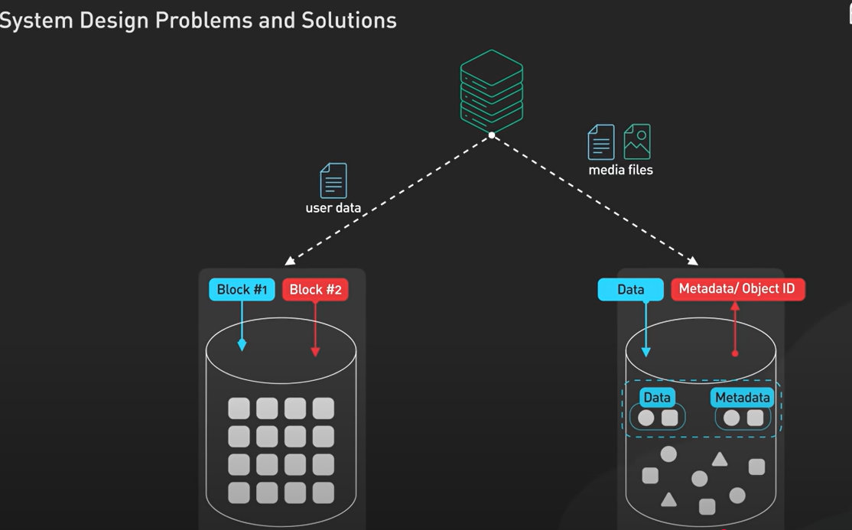

System monitoring –

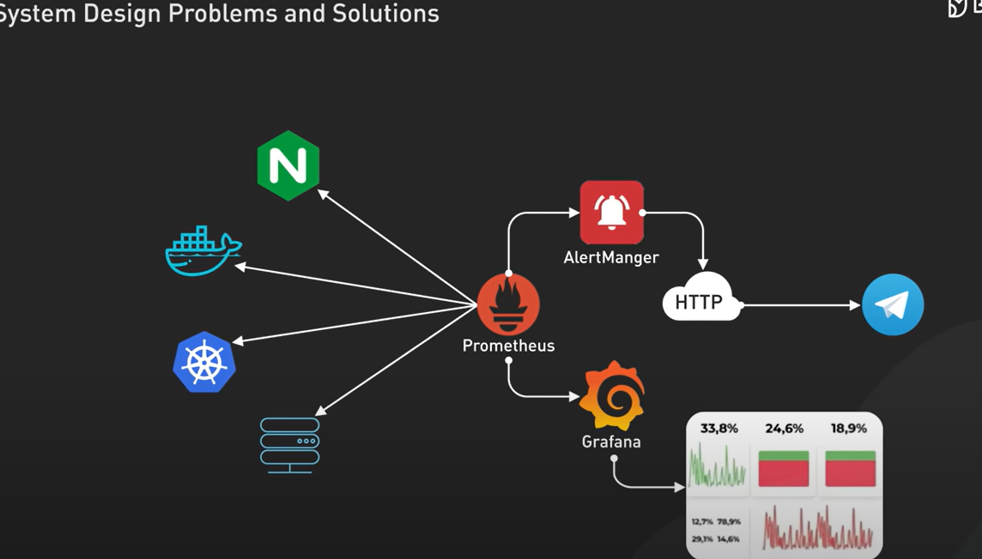

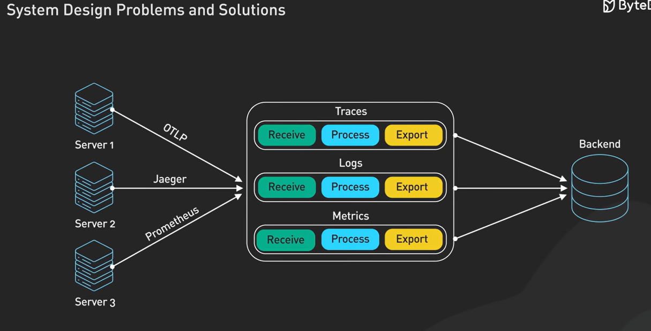

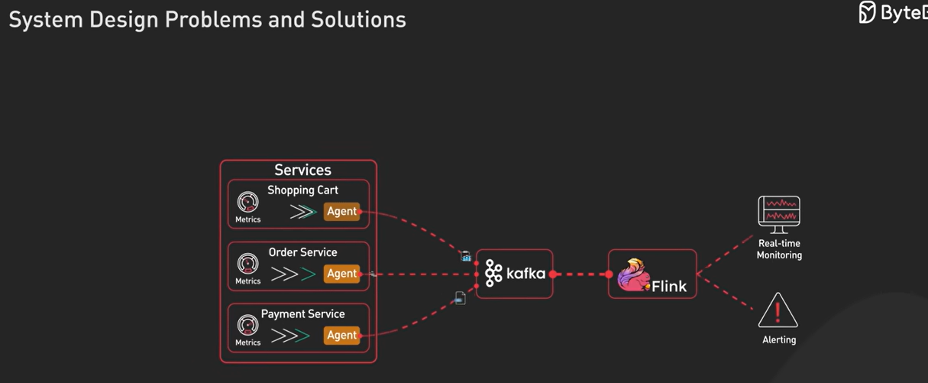

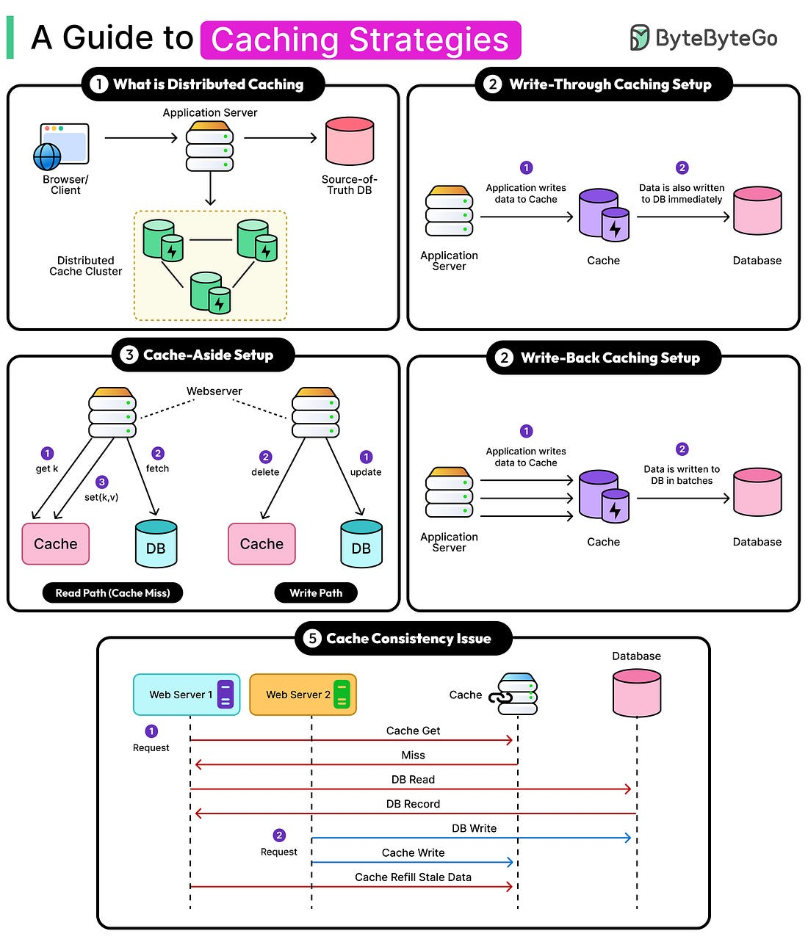

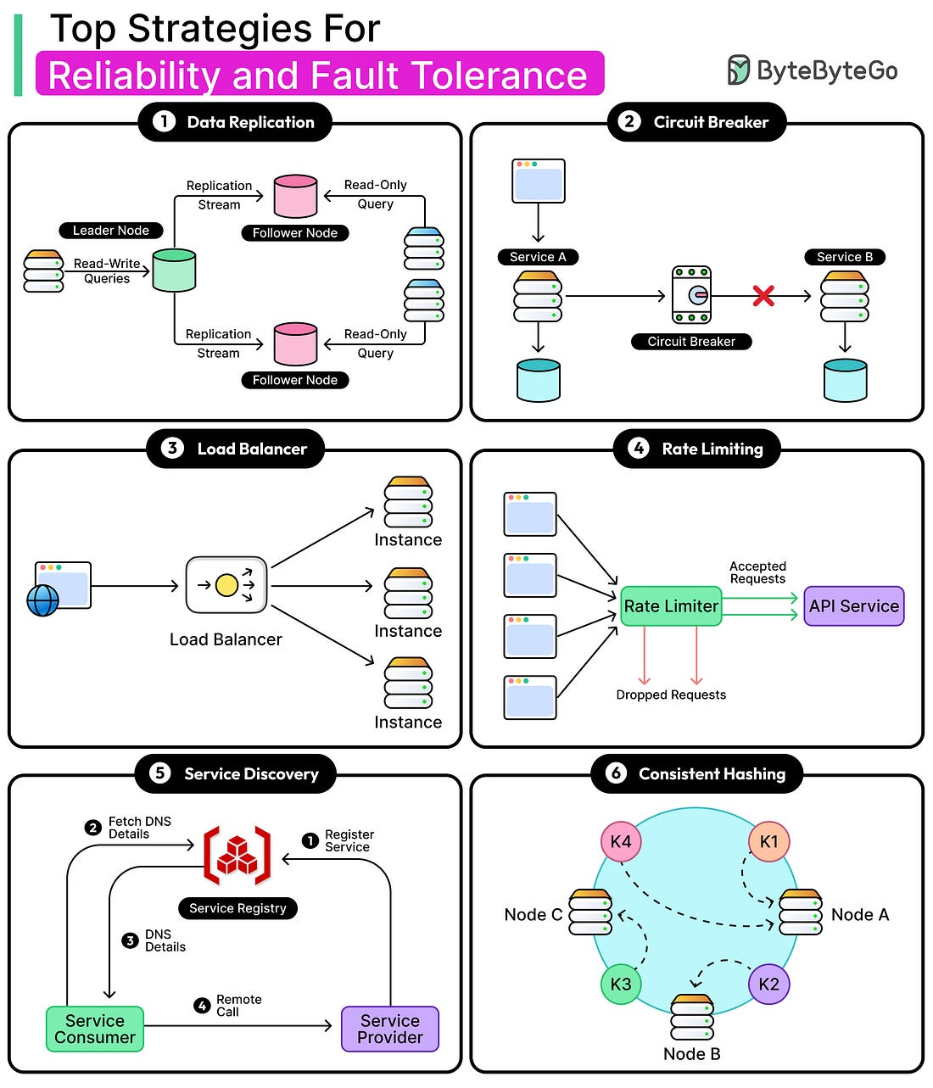

Database sharding is to split the data into multiple machines.